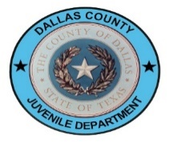
PREA Reporting an Incident of Sexual Victimization
I am reporting an incident of sexual victimization and included the relevant details below. By providing my contact information, I understand the Dallas County Juvenile Department Compliance Unit may return contact.
Identification Information:
Reporter name (optional): | Reporter email address (optional): | Reporter phone number (optional):
Victim’s name: | Victim’s DOB (if known): | Alleged Perpetrator’s name:

Names of Witness(es):
Date of the incident: | (if unsure of the date, please provide day of week, month, etc.)
Time of the incident:

Below is a list of the county-owned facilities:
Dr. McNeil Juvenile Detention Center
Marzelle Hill Transition Center Shelter
POST Residential Programs
Dallas County Youth Village
Lyle B. Medlock Residential Treatment Center (RTC)
Letot Center Shelter
Letot Residential Treatment Center (RTC)

Please indicate the above facilities the incident occurred. If it occurred in another facility or program, please provide as much information on that facility as possible below:

A detailed description of the incident:

Once completed, this form may be printed and faxed to the attention of the DCJD Compliance Unit at 214-698-4247, or emailed as an attachment to DCJDPREA@dallascounty.org.

