Contents
Security Error Resolution 1
APSPECFND Entry Template 2
File path and Filename for Send 2
Customize the Template for your fund: 3
Using the Entry Form continued 3
APIO_File Tab (Request review and edit) 4
Substitution Rules: 5
Append Tool: Combine files from sections before sending to Oracle 7
Approval Notifications: 8
Notification Work Around 9
Daily Status Notifications: 9
Employee changes after Go-Live 15

Accounts Payable Invoice Onboarding (APIO) an extension of Fusion Accounts Payable an Oracle system. This extension provides handling of payment requests in a uniform manner. APIO receives requests for payment to suppliers or payees (special funds) from departments, suppliers and other applications. APIO supports a self-service model where persons/applications can place files on their network directory and review/approve once Oracle picks them up.

Security Error Resolution
Recent security changes are requiring an additional setup for the template workbook. This is needed per computer and user. The location of your workbook must be a trusted location. If you need further assistance contact the Servicedesk or try these instructions.

Navigation
Files -> Option -> Trust Center
Click Trust Center Settings Button
Select Trusted Locations (Left hand Menu)
Check Allow Trusted Locations on my network (Not Recommended)
Review User Location Paths (I recommend you add you J, K and G drives and if you plan to place your template on your desktop add the desktop as well)
Click Add location button
Click Browse Button
Navigate to a drive or network location
Click OK
Check Subfolders of this location are also trusted
Click OK
You can brows to another location or click OK until all the dialog boxes are closed.
Close Excel and re-open.
APSPECFND Entry Template: An Excel based user interface that reduces data entry, validates common entry errors, and produces a file that meets required formatting. Note: This screen shot does not have the Fusion changes. They will be addressed later in tis document.

Entry Form instructions are in the area to the bottom right-hand corner see the red square. You can scroll through these instructions Make sure you scroll back up or click Start new to reposition for entry. Field titles are often color coded in these instructions to help you identify them on the form. Additional documentation is available in the titles that have a red mark in the upper right-hand corner. Buttons are raised objects that have colored text. You click Buttons with your mouse to initiate actions. Payment data entry areas are enclosed in a purple square. Use your tab key to move from one entry field to another.

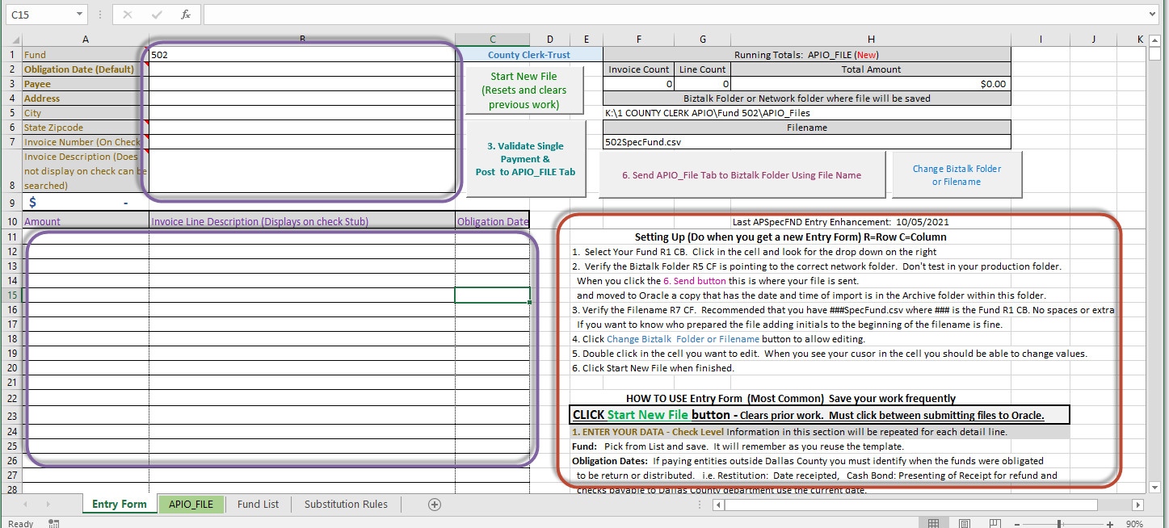
File path & File name for Send
Check Total

Tabs are at the bottom of the workbook and tabs have different functions you can navigate to a different tab by clicking it with your mouse.
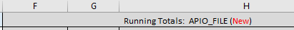This section will give you your progress, these are always calculated values. DO NOT unprotect and modify them.
- When you start a new payment request. APIO_File (New) will be presented.
- Once you have successfully validated your first check this status changes to APIO_File (In Progress). You will also note that the Invoice Count, Line Count and Total Amount will have values. These statistics represent the totals for the APIO File that would be generated when you click the 6. Send APIO_File … button. Totals are updated when buttons are clicked.
- When you complete the “Send” action the status this status changes to APIO_Files (Sent to Oracle)

File path and Filename for Send: Identifies where the file will be sent. When you select a fund it will reset to your “production” folder designated for APIO file. You can find the production and test Biztalk folder paths on the Fund List tab next to each fund. Use the Setting Up instructions on the Entry form to change the folder and file names to represent the special fund being processed.

Note: There is an Archive folder within the Biztalk folder. When BizTalk picks up the file. It will always archive it (make a copy with a date and time stamp) before it releases it to Oracle.

Customize the Template for your fund: It is recommended that you remove the funds that do not apply to your business unit from the Fund List. This will prevent a novice user from changing to an inappropriate fund. In addition, you can protect the Address line 2, Address Line 3 and the invoice description from entry. The Invoice Description is useful for documenting information about the check for internal search and review. It is not presented on the check stub or check. Review the blue comment box on this tab that will define your options further.

Create a copy and set up the Entry form and assign one to each person who builds the files. (Optional)
  - They can use their initials on the filename to show who did the entry.
  - They build files in parallel just sending them at different times.

Using the Entry Form continued

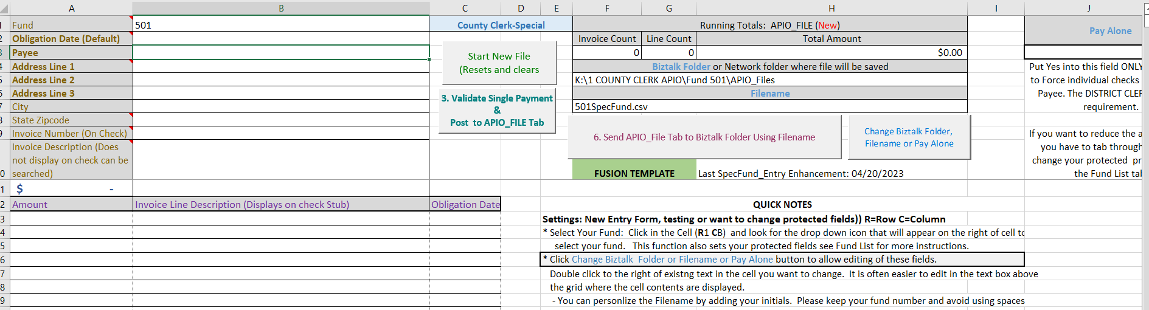Details including most field explanations are in Notes section of the form. They have been copied here for your benefit.

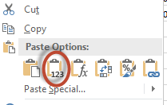
You may use copy and paste from another worksheet. Into the entry areas. HOWEVER!!!! Always paste values. Excel Formats are very important. Use the circled option from the right mouse click menu to paste.

HOW TO USE Entry Form
CLICK Start New File button - Clears prior work. Must click between sends.
1. ENTER YOUR DATA - Check Level Information in this section will be repeated for each detail line.
Fund: Pick from List and save. It will remember as you reuse the template.
Obligation Dates: If paying entities outside Dallas County you must identify when the funds were obligated
to be return or distributed. i.e. Restitution: Date receipted, Cash Bond: Presenting of Receipt for refund and
for payments to other Dallas County department use the current date.
TIP: On line 2 enter the most common date for your batch and on rows > 12
Enter the Obligation Date only for the amounts where the Obligation date falls in a prior month.
Address: CPU= Customer Pick Up, C/O + Name will not require additional address entry
Invoice Number: Blank = Auto Number or enter unique value (i.e. Check Number/Receipt from another System)
The resulting invoice number will always begin with the Fund.
Invoice Description: Great for internal documentation available on reports.
2. ENTER YOUR DATA - Line level - Appears on Check Stub one or more lines as needed
Amount: The amount associated with the case or other county business
Invoice Line Description: Describe purpose of the detail amount and each line will display on the stub.
Obligation Date: Enter a date here only if the Obligation date is different than the Obligation Date (Default).
4. Is this a Pay Alone situation? Change the Pay Alone Setting (Instructions Above)
5. Click 3. Validate Single Payment & Post to APIO_File Tab button
6. Repeat 1-4 until all payments are addressed on the APIO_FILE tab
6. Review APIO_File tab (You can unprotect and delete rows for re-entry)
7. Click 6. Send APIO_File to BizTalk Folder Using Filename button.
- Creates File using the Filename provided into the Biztalk Folder designated.
- Check Archive Folder within Biztalk Folder for backup and submission history
- Notification should be received every 10 minutes from the top of the hour.

APIO_File Tab (Request review and edit)
Before “Sending” data you or a supervisor may want to review all the data together. Navigate to the APIO_File tab (green).
In the Excel ribbon click Unprotect Sheet.

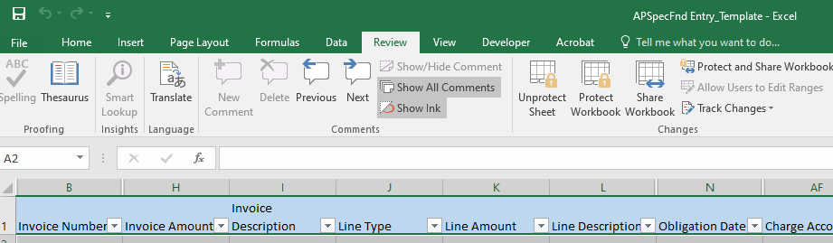

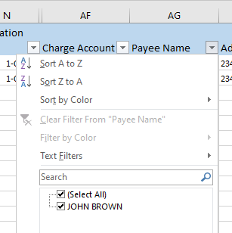
You can now sort or filter all the data on this tab using the down arrow on any column. This example is sorting on the Payee name. The entry form will protect and resort when you click the ‘Validate” or “Send” buttons. You can use the search to select certain values and hide the rest.

Only edit single line payments. If you need to “fix” a multi-line check you should Delete the rows and re-enter. There are 45 columns on each line and there are some critical columns that you may not know to change when you are fixing.

You may also copy and paste from another Entry full rows only. Always paste values. Excel Formats are very important. Use the circled option from the right mouse click menu to paste.

Substitution Rules:
The Entry Form supports a rules-based entry for those who frequently have to send money back to Dallas County for deposit by the County Treasurer or application to another Dallas County application (i.e. for fees and fines in criminal courts).

Reduces data entry, allows entry out of sequence but information is still summarized for payment by Payee and GL designation. Supports APIO Deposits which reduces deposit posting errors and data entry by the Treasurer.

You must consult with the Auditor’s office on how to best use this functionality for your office if you are interested. Some of the features available are the following. The fund would use two-character codes on the line description to trigger a rule from the rules tab. The following are set up.

- Substitution of payee, address, invoice, and line descriptions.
- Parent code: The line description from the parent code will be presented on each of the child line descriptions.
- Validation ensuring parent child relationships.
- Use N/A as the payee for different substitute Payee saving entry.

Here’s an example of a cash bond receipt being processed for refund (502). In this scenario, the surety “Randy Patterson” is receiving a portion of the bond, some will be re-applied to other cases pending for the defendant, Administrative fee and a stop payment fee.

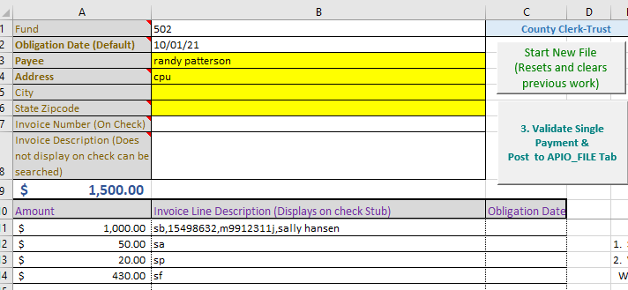
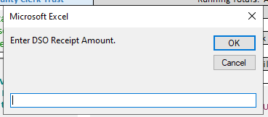
The rule for the SB also requires a confirmation entry of the DSO bond receipt amount to avoid over or under application.

The validation process created the following entries consisting of four checks. However, three checks will combined with other like business within the same payment batch. Resulting in one check for the entire APIO File to the 120 General fund for deposit into 120.0.45510, 120 General Fund for deposit into 120.0.45153 and one to County Clerk with stubs with case information attached.

Invoice Number | Invoice Description | Line Amount | Line Description | Payee Name | Address
*AF | 1.00 00120.0000.45510.0000.4003.00000.00000.0000 | 50.00 | CC 15498632 M9912311J SALLY HANSEN | 120 GENERAL FUND | APIO Deposit
*CC |  | 430.00 | CC 15498632 M9912311J SALLY HANSEN | DALLAS COUNTY CLERK CRIMINAL-CT COST | DO NOT MAIL
*SP | 1.00 00120.0000.45153.0000.1003.00000.00000.0000 | 20.00 | CC 15498632 M9912311J SALLY HANSEN | 120 GENERAL FUND | APIO Deposit
502-211015135059 |  | 1000.00 | CB 15498632 M9912311J SALLY HANSEN | RANDY PATTERSON | CPU

No parents: This scenario involves a number of cases but all the funds are going to the County some for deposit and some applying to other applications. The cool thing is that you don’t have to have payees as they all come from the rules.
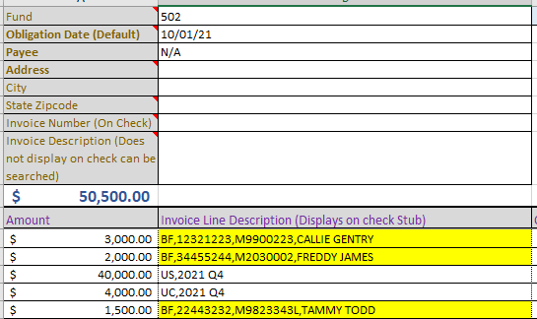
The highlighted lines had format errors before this screen shot. The DSO Receipt number in the second position had been seven characters instead of the required eight.

Invoice Number | Invoice Description | Line Amount | Line Description | Payee Name | Address
*BF |  | 3000.00 | BF 12321223 M9900223 CALLIE GENTRY | DALLAS COUNTY CLERK CRIMINAL BOND FORFEITURE COST | DO NOT MAIL
*BF |  | 2000.00 | BF 34455244 M2030002 FREDDY JAMES | DALLAS COUNTY CLERK CRIMINAL BOND FORFEITURE COST | DO NOT MAIL
*BF |  | 1500.00 | BF 22443232 M9823343L TAMMY TODD | DALLAS COUNTY CLERK CRIMINAL BOND FORFEITURE COST | DO NOT MAIL
*UC | 1.00 00120.0000.48030.0000.1003.00000.00000.0000 | 4000.00 | Unclaimed Property to Dallas County 2021 Q4 | 120 GENERAL FUND | APIO Deposit
*WR | 1.00 00882.0000.10010.0000.0000.00000.00000.0000 | 40000.00 | Unclaimed Property to State 2021 Q4 | 882 WIRE TRANSFER | APIO Deposit
The invoice numbers are assigned when the file is created this is how we create one invoice for entries over time.

Append Tool: Combine files from sections before sending to Oracle
Prerequisites:
- Identify a department folder to place file in your K or G drives.
- Set up a Template for each Section sending files for combination.
  - Update the BizTalk Path to point to department folder above.
  - Update the Filename to reflect the section
- Collector will use the production BizTalk folder but will change the #1 Append Tool
  - Each line will point to the department folder, specify a section filename, set APIO File to “Y” and set the Open flag to “Y”.

Process:
- Sections will build their request APIO_File and will send it.
- The collecting section will use the Append tool to add the other sections to their own data.
- Send the Combined file to the production Biztalk folder that defaults in when the fund is changed.
- Collector will click the #1 Button. The content of the files will be added to the end of the APIO_FILE tab.
- If a file is missing and the process terminates change Open to “N” for files read and the missing file(s). Retry.
- Remove files from the department folder to prevent issues on next execution.
- Reset Open to “Y”.

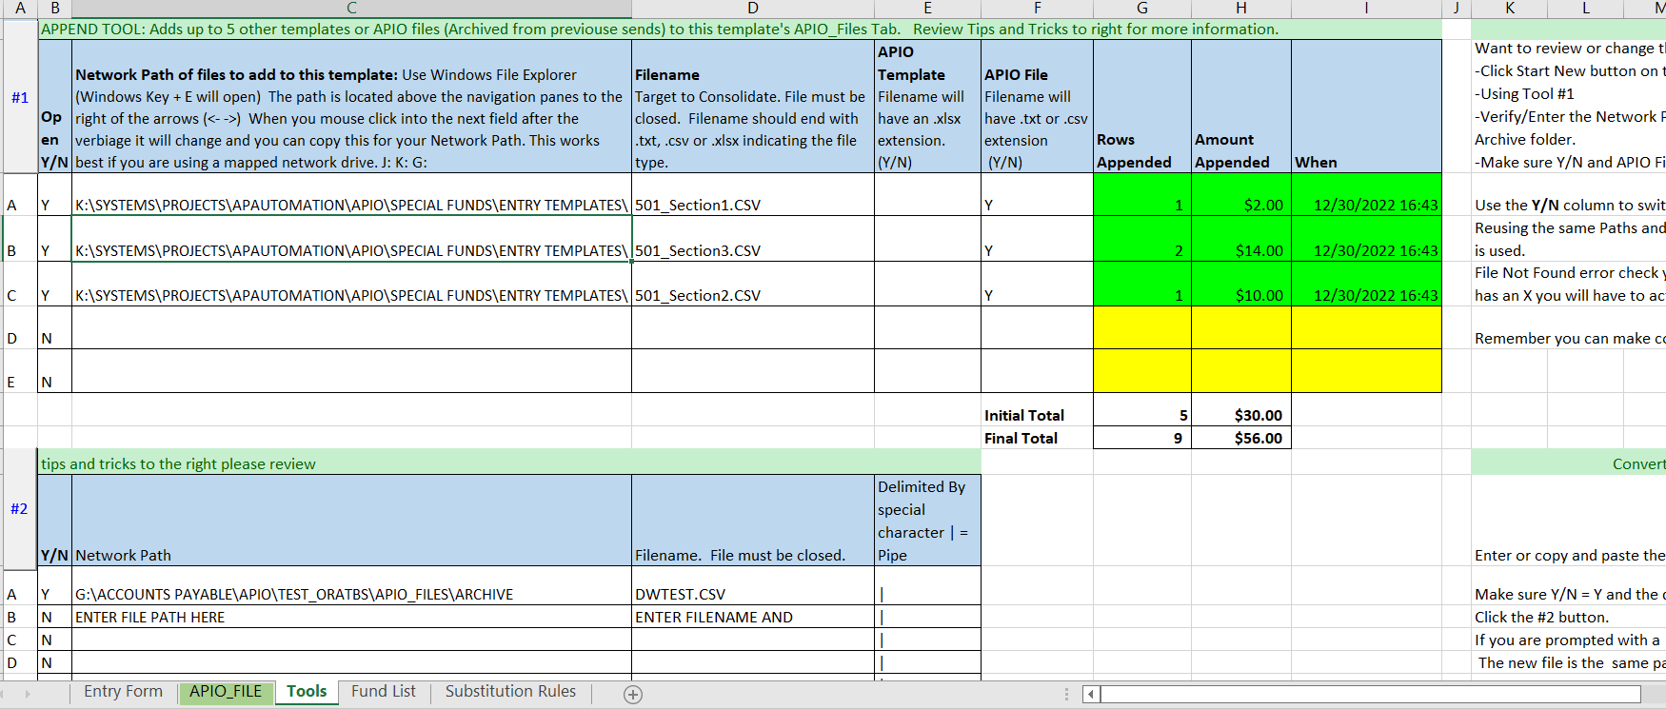
Using this method, you will only use the APIO File option as indicated in this screen shot. If you wish the same effect can be done using excel templates and the APIO Template column.
Instructions are in the text box.

Approval Notifications:
When BizTalk delivers your APIO File to the APIO system it is picked up every 10 minutes from the top of the hour. Usually emails are received within the minute.

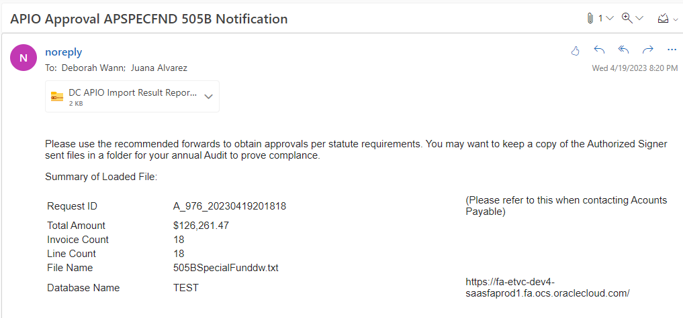
1
5
2
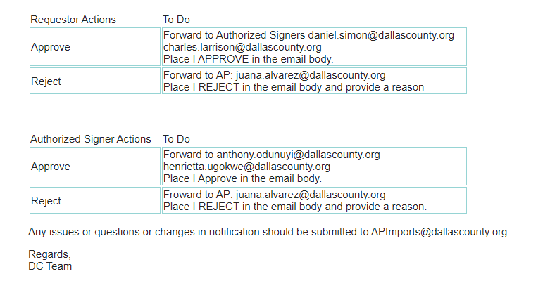
4
3
Notification Components
- Subject will identify the following.
  - The Special Fund being processed
  - The action if it is an approval or FYI notification.
- APIO_File verification and identifiers.
  - The Request ID is critical for communication with the audit and Accounts Payable teams.
  - The Invoice Total, Invoice Count and Line Count should always agree with your running totals on your Entry Form.
  - Database name: If it is not PROD or PRODUCTION you are dropping files in to a test instance.
- Requestor Instructions. Small Departments if your bookkeeper is out the first Authorized signer will get the email. Ideally in this situation the Judge or department head would perform the Authorized Signer duties preserving the separation of duties.
- Authorized Signer Actions. Review the totals and the Attached report of submitted data (5) Forward to next email addressed depending on decision Note

Notification Work Around
In testing notifications are usually received within a minute of the next 10-minute interval. If you do not receive a notification in 20 minutes. Check your BizTalk folder and Archive folder to see if the file has been picked up we will want to know that and we will contact IT.

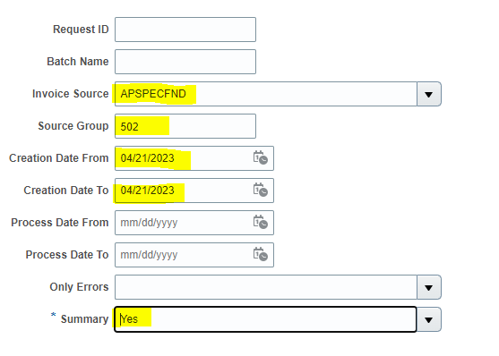
If the file is in Archive like it should be you can run the fusion DC APIO Import Results Report.
Use the following parameters and the same steps for the DC AP Invoices with Payments Excel report later in this document.
- Source Group should be the same as the Fund on your template.
- Creation date range to cover when you dropped the file
- Summary is Yes if you just want the total and the Request ID. Use No if you want file returned in report form for review.

Contact: Deborah Wann, Daniel Tshibamba or email APImport@dallascounty.org

Daily Status Notifications:
The first Requester and the Final Notify will receive a summary status email. This email will tell you if APIO received the file and if they received the proper approval notification. If there was an error in processing the failed data will be in the attachment. You will have to fix and re-submit.

I have not received a failure yet with special funds. So if this does occur you should seek assistance.
Contact: Deborah Wann, Daniel Tshibamba or email APImport@dallascounty.org

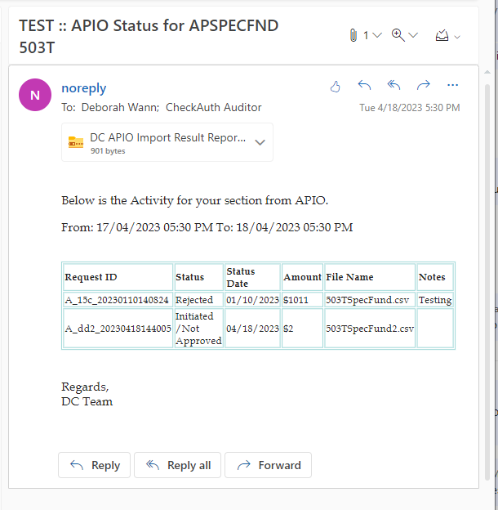

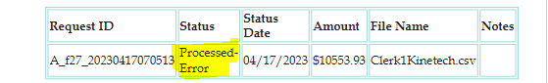

DC AP Invoices with Payments Excel
This report shares many columns with the DC GL Actuals with Invoice Details Excel report so it could be appended to the end of that report. This report includes Oracle Payment information.

This is the home page. Click the triple dash to left of County seal
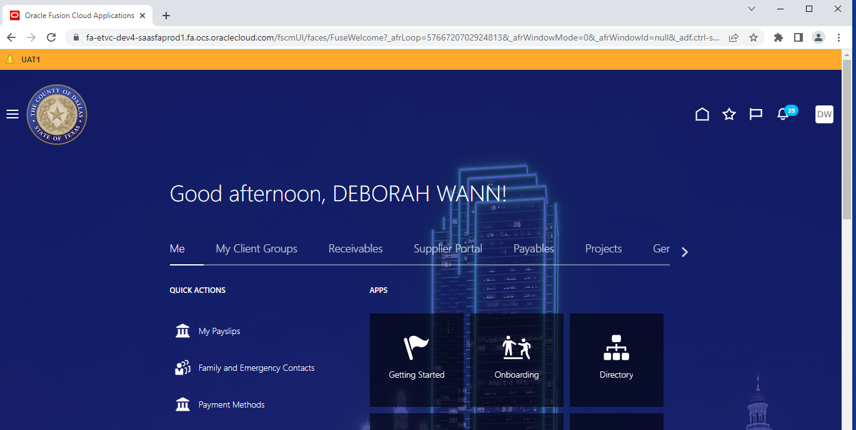
1
Choose Tools and from the next menu choose Scheduled Processes.
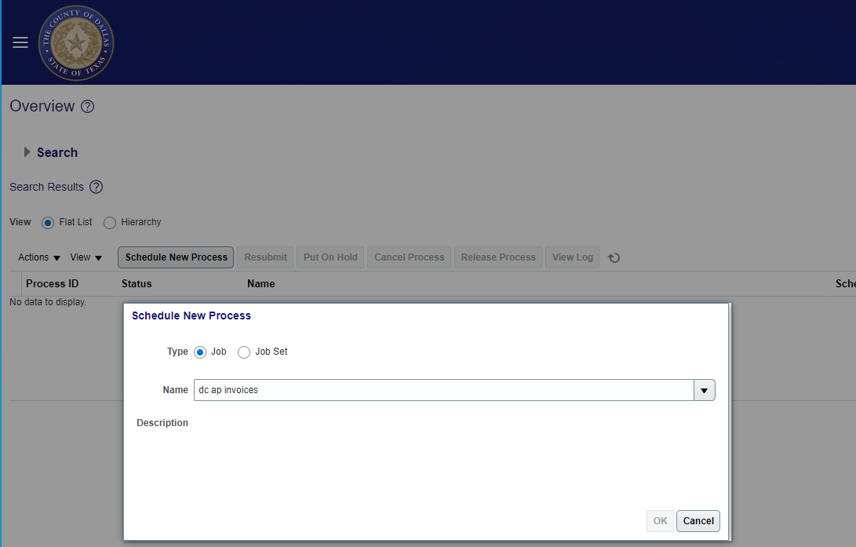
1
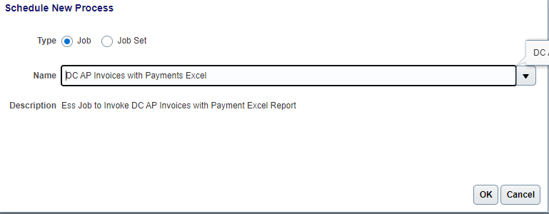
- Click the Schedule New Process button.
- Enter all or part of the process name in the name box.
- Click Enter or use the Down arrow key.
- Click OK

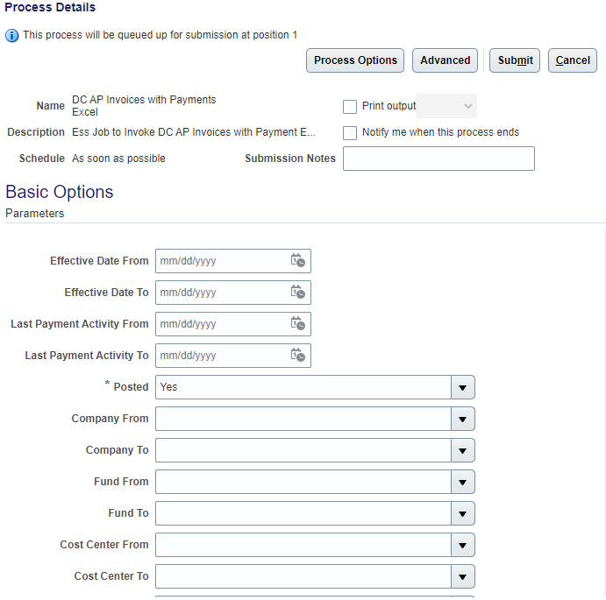

For reconciling the activity or retrieving payment numbers for a fund.
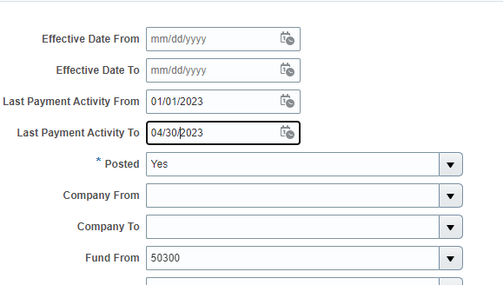
- Enter the Effective Date From and To (This is usually the same as the creation date in Fusion for special funds as we tend to import and Pay same day.
- Enter your Fund number in the Fund From and To. In fusion the fund has the two 00 after the fund number i.e. 50100.
- Posted set to Both. We only account in the evenings so if you are in a hurry this is the parameter to choose if you think the file was approved by the cut-off time of 2 pm.
- Click the Submit Button
- Click OK on the process id.
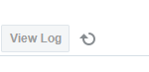
- Click the refresh symbol to right of View Log button to see the active process.

- Click the process is done Succeed will be displayed

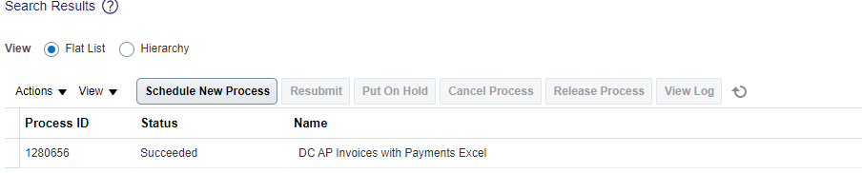
- Click on the job line and more Process Details to be displayed.
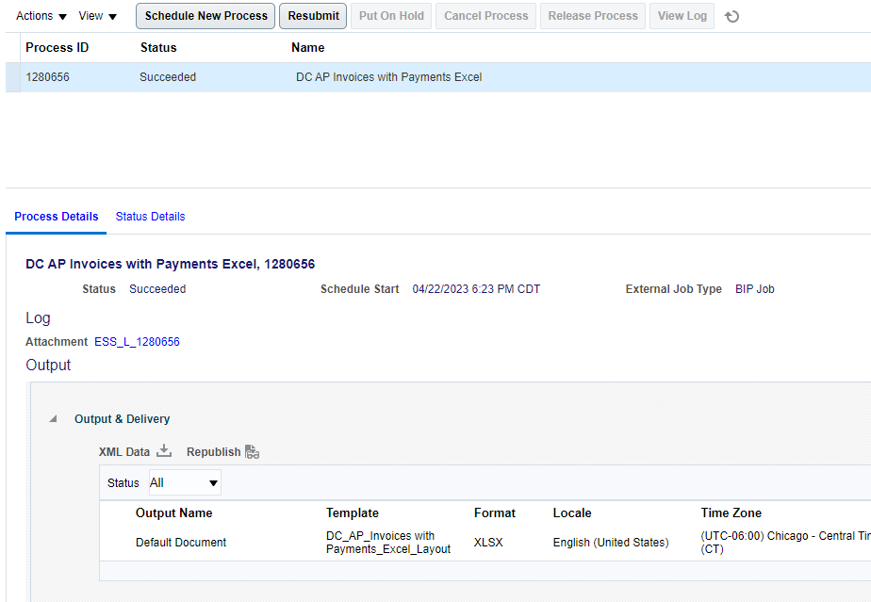

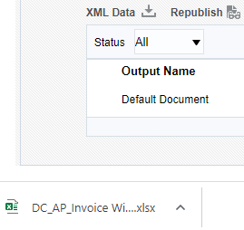
- Click Default Document link beneath Output Name.
- This will download the report to your downloads folder. There Is a link at the bottom of your Fusion window.
- Click the report to open.

Report Output columns: For special funds the most relevant columns are highlighted.
Column Name | Column Description
Source // Category | Will only have “Payables // Invoices” in this column
Account Combination | Invoice distribution account combination
JE Batch Name // JE Journal Name or Invoice Description | Reflects the description of the invoice. Information that typically applies to entire invoice.
JE Line Description or Invoice Distribution Description | Invoice distribution description. Most likely to tell you what exactly was paid for.
Effective Date | Invoice distribution GL date also known as the accounting date.
Amount | Invoice distribution amount that applies to the account combination.
Invoice Number | Invoice number (Fund)+Section Letter+Date and time YYMMDDHHMMSS
Invoice Date | Invoice date
Vendor Name | Invoice vendor name (Same for all special funds)
PO Number | Invoice distribution PO number
Invoice Amount | Total Invoice amount
Status | Paid = Distributions has been paid  Accounted = Expense is recognized but payment not issued yet.  Canceled = Invoice has been canceled. If accounted and canceled in same months the amount should be 0.
Unit Price | Unit Price of the item being purchased. This can be used to calculate how many items were paid for or if the item is a fixed asset.
Vendor Number | Vendor Number to be paid – Number is assigned in Oracle.
Atty Bar No* | This will display the bar number of attorneys. This is populated to support tracking of attorney payments made within County courts.
Fund – Future* | Account combination segments: Use these fields for sorting and filtering.

Payment Information that is only on this report.
Column Name | Column Description
Invoice Received | The Date the invoice was received by Accounts Payable
Invoice Created | The Date the invoice was created in Accounts Payable
Service Start | The start date that the goods were receipted, the service provided or the effective date for an obligation to pay
Service End | The end date that the goods were receipted, the service provided or the effective date for an obligation to pay
Payee Name | This is the name printed/applied to the payment
Payment Amount | Total Amount of the payment
Payment Count | Oracle can void and re-issue payments for the same invoice. This is the total number of times that the Issue activity happened for this payment.
First Pay Activity | Date of the first issued payment.
Last Pay Activity | Date of last payment issue or void.
First Payment Number | First Payment number for this invoice
Last Payment Number | Last Payment number for this invoice
Last Payment Status | Current Status of the Payment (VOID without an Invoice Status of Canceled indicates the payment maybe re-issued.) Also identifies if the payment has been cashed or not.
Pay Group | This will help identify the payment method if it is check it will start with FUND followed by the fund number.
Invoice Approval Status | Payment can be held waiting for invoice approval. Imported invoices are automatically approved. Other invoices my require separate approvals before payment by the office or auditors.
Invoice Source | Identifies how invoice was created. If imported it will have the import source name.

- Use the Auto filter options.
  - Position your mouse on line 21, the report detail header any cell.
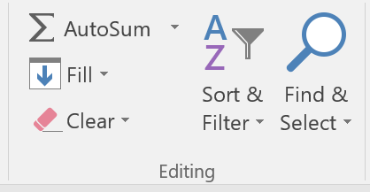
  - Use the excel tool bar to position to the Data tab.
  - Click Filter. (The same function is on the home tab. In the Editing section at far right.)
  - Hover over the filter option to see a good tutorial on what this can do for you.
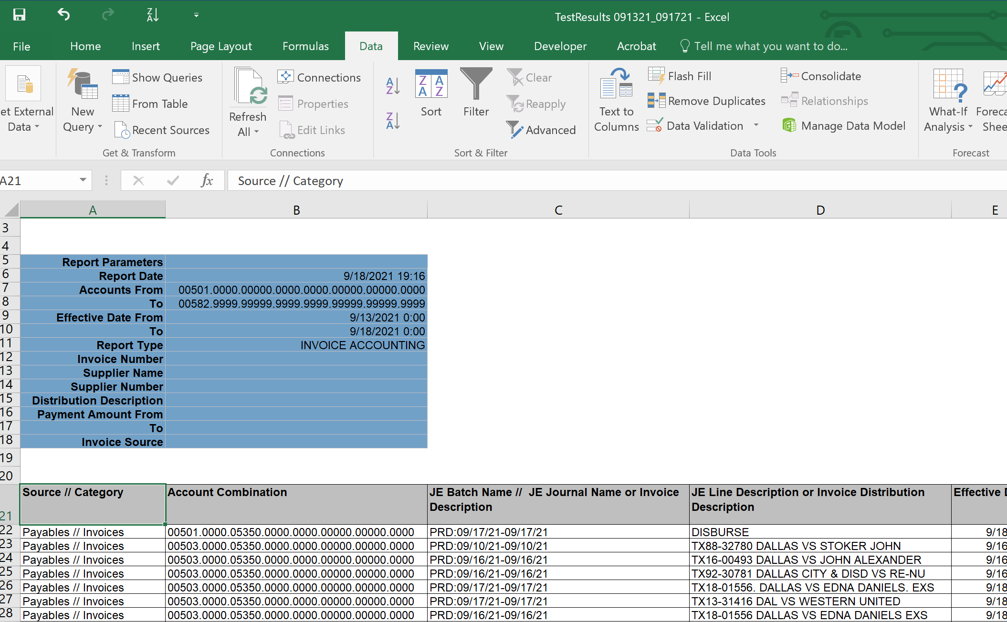
c.
b.
a
When you see the little drop downs on each column you can filter and sort with ease.
Employee changes after Go-Live

New Approvers. Start an email.
Email Payables@dallascounty.org
Copy APIMPORT@dallascounty.org

Subject: APIO Approver Change
In the body copy and paste this. Or just provide the email of the new approver and what position they are holding. We will also accept the name of the email to be replaced. For the Final notify we can accept a proxy email address. Internal Audit will want proof of separation of duties on the approvals.

Special Fund:
Requester1:
Requester2:
Authorized Signer1:
Authorized Signer2:
Final Notify:

Please make sure to provide your fund number.

