Table of Contents (Lookup by what I am trying to do)
Quick Report Reference 2
Common Features 3
Navigation 3
Reporting Criteria and Parameters 3
Preview Options 5
Security Audit/ Setup 6
Security Audit: Role -> Function 6
Security Audit: User -> Roles, Locations & Sources 6
GL Accounts: GL Fund Mapping 6
GL Accounts: Oracle/Class Exceptions 7
POS Items: (Fee schedules, Accounting, Grouping, Audit & Prompts) 7
What can a deposit source sell and how is it presented? 7
Researching & History 8
Receipt Transactions: Details 8
Receipt Transactions: Cancellations 8
Receipt Transactions: Price Adjustments 8
Receipt Transactions: ENHANCED (Export, Additional reporting) 8
Accounting: DC98 Deposit Warrant or CSS 9
Accounting: Summary by Transaction or Reset Date 9
Accounting: Transaction Receipt Level 9
Accounting: (GL Effective Date, Source & Monthly Summary) 9
Suspense Accounting: What transactions cause interface issue 11
Items: Total sold – Performance Measures 11
DC23 Item Sales Summary: Prompts 11
DC24 Item Sales Detail 11
Departmental Closeout 12
Determine On-hand amount totals by Cashier 12
Departmental Cash Count Audits 12
Receipt/Transaction List (Active/Historical) 12
Receipt/Transaction List (Multi-Tills) 12
DC98 Deposit Warrant 13
Bank Deposit Management & Research 13
Distribution of Funds from a payment Channel (Deposit to Cash) 13
Proof of Cash – Daily impact from all payment channels 14
List Departmental deposits within a Bank Deposit 14
Locate Departmental Deposits not received/processed by Treasurer 14
Determine the CSS batch number after Departmental Reset 14
Locate Receipting Sessions not properly closed out 14
History of Department to Bank Deposit activity 14

Quick Report Reference
Use the Section and the Base Report to navigate to the desired DC report. Bolded reports are most useful for Receipting Departments.
Report Title | Section | Base Report | Description
Accounting Reports
DC10 Accounting by Month Go | Accounting | GL Report (Summary) | Revenue Forecasting, Trend analysis, GL impact
DC11 Accounting by Receipt Go | Accounting | GL Report (Detail) | Accounting detail per receipt
DC28 Accounting by Deposits Go | Accounting | GL Report (Summary) | Deposit level accounting can replace DC98
Configuration Verification Reports
DC1 Security Audit: User Go | POS Lists | POS User Listing | Users and related roles
DC29 Security Audit: Terminal Go | POS Lists | POS User Listing | Users and Terminal (Deposit Locations)
DC5 Item Listing Go | POS Lists | Item Listing | Item setup/Fee schedules
DC2 Security Audit: Roles Go | POS Lists | POS User Listing | Defines Roles to Functions
DC3 Accounting Setup Go | Accounting | GL Chart of Accounts | Verify Fund Mapping
DC4 Accounting Setup Exceptions Go | Accounting | GL Chart of Accounts | Set up exceptions
DC30 Items w/Related Prompts Go | POS Lists | Item Listing | Lists Items and related prompts
DC26 Lookup List Go | POS Lists | Lookup List Listing | Lists used for cashier buttons
Parent Lookup List Listing Go | POS Lists | Parent Lookup List Listing | Shows lookup list of lookup lists
DC29 Security Audit: Terminal Go | POS Lists | POS User Listing | Defines User to location/terminals
Receipt Transaction Level Reports
DC6 Receipts Go | POS Sales | Journal Listing | Receipt details
DC7 Receipts: Cancelled Go | POS Sales | Journal Listing | Cancelled Transactions only
DC8 Receipts: Adjusted Go | POS Sales | Journal Listing | Receipts with price adjustments
DC31 Item Sales Report Go | POS Sales | Group Item Sales Report | Statistics by item
DC16 Payment Listing Go | Accounting | Daily Cash Balance Report (Detail) | Reconcile Receipts/ Check Register. Totals by pay type
DC32 Receipt Recon by Group Go | Accounting | Daily Cash Balance Report (Detail) | Payments w/Totals by type/deposit uses reporting groups
DC22 Receipts Export Go | POS Sales | POS Custom Prompt Transaction Report | Transaction/Item level details excel friendly format
Department Deposit Management Reports
Drawer Balance Report Go | POS Sales | Drawer Balance Report | On hand amounts – per Till/Cashier Totals only
DC98 Deposit Warrant Go | POS Sales | Reprint Cash Summary Sheet | Deposit Warrant
Deposit Management – Not Reset Go | Accounting | Deposit Management Report (Not Reset) | CSS sessions pending in Dept.
DC13 CSS Deposit Status Go | Accounting | Deposit Management Report | Deposit reset but not at Bank
DC17 Deposit History Go | System | Custom Reports | Deposit Tracking (Reset, Treasurer Receipted, Bank Deposit)
DC21 Over Short Summary | POS Sales | Cash Summary Over/Short Report | Lists O/S at dept. closeout
Bank Deposit Impact Reports
DC15 Bank Deposit: CSS List Go | System | Custom Reports | Bank Deposit listings of CSS
DC19 Bank Distribution: Deposit Go | System | Custom Reports | Bank account impact by Deposit
DC27 Suspense Transactions Go | System | Custom Reports | Find source of suspense accounting

Common Features

Navigation
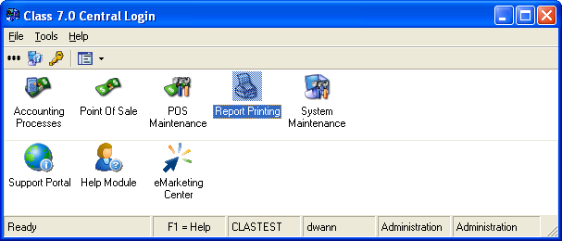
Supervisors and those with Inquiry access can run reports. All reports are run from the same place the Report Printing Module.

The Reports module can be reached from the Central Login Screen by choosing Report Printing icon or from Point of Sale using the Modules button and selecting Report Printing.
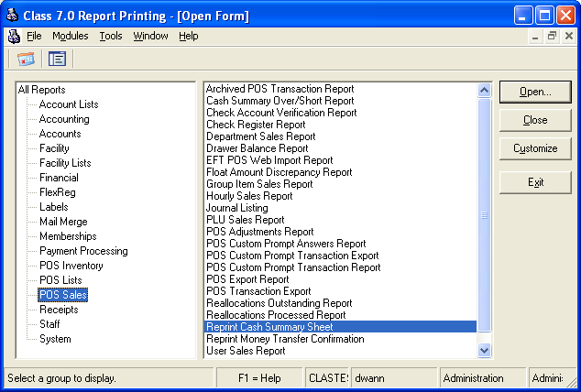
Section
Base Reports
The Report Navigation Screen will be returned. Reports are categorized by section (left side of screen) and related base reports are listed on the right

Reports enhanced for Dallas County will always be under one of the base reports and will usually be displayed after some reporting criteria has been selected.

As you review this documentation you will see what section and base report and enhanced report (if applicable) applies to each business function being performed.

You can navigate to the base report by double clicking with your mouse or highlighting and clicking open.

There are a large number of reports on this system. It is important that those reports that are used in Class are identified. They will need to be tested with each upgrade even those that have not been enhanced.

Reporting Criteria and Parameters
The class reports that used here at Dallas County share common features. Instead of repeating these features and related best practices for each report they will be discussed here.

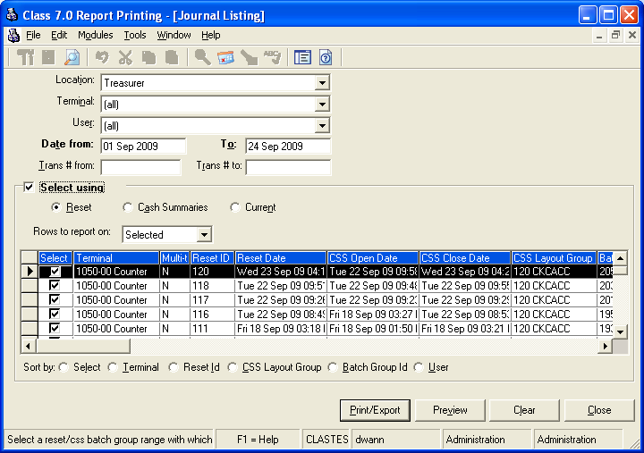
AVOID pressing ENTER on this screen. It will automatically cause the report to print

Location: The location allows you to select the department where receipt transactions were created. If you want data for a specific department you will have to make sure that department is displayed here. If you want data for multiple departments change this to [all].
Terminal: The terminal allows you to select the specific deposit source where receipt transactions were created. You can only choose a terminal if you have already chosen a location.
User: Users are going to be cashiers. The list will display other users of the system supervisors, administrators, etc. but, but this user is always related to who created the receipt transaction. You can choose a user without choosing a location or terminal. A practical use of this would be to see how many receipts a roving cashier may have entered at each deposit source over a period of time.
Date from-To: This always refers to the receipt transaction date except when using the Select Using criteria option. In this case the date range will be used against the Select Using option selected. HINT: When using parameters such as CSS Batch (Deposit Warrant) or GL Effective date you will want this date to be very wide usually a year on each side (unless it is in the future) of the date range that you are actually targeting just to be safe.
Transactions From-To: This helps search for specific receipt numbers/ranges. Since all departments will be sharing the same receipt number sequence this range will in most cases bring in other departments information.
Select Using: This feature allows you to choose receipt transactions data based on other dates/events in the system. When you check the Select Using check box the grid will populate with the default Reset batches (current default) that match the transaction previously entered.
- Reset - This is the control number and date associated with the close of a receipting session
- Cash Summary aka CCS Group – This is the control number and date associated with the opening of a receipting session.
- Current - Should list CCS Groups that have not been reset. This feature doesn’t use the date range. (Note: Do not use this feature on base reports that do not have the Cash Summary option they have not been enhanced to support multiple open sessions.
Rows to Report On: This should be set to Selected when you run the report. HINT: If you are hunting for a specific reset you can use a wide date range and change this to None and all the returned resets will be de-selected for you. You can then go and click just the one(s) you wan, when you select from the grid box this option will return to Selected.
Buttons: It is recommended to always use Preview first to look at the report and make sure it is what you want. Either of these buttons will start the execution of the report.

If a base report has Dallas County version or can be run on a receipt printer you will be prompted to choose a report version. The report chosen may have special parameters that are not available on the base report. These will be presented when you press OK on the report lists.
Parameter Values
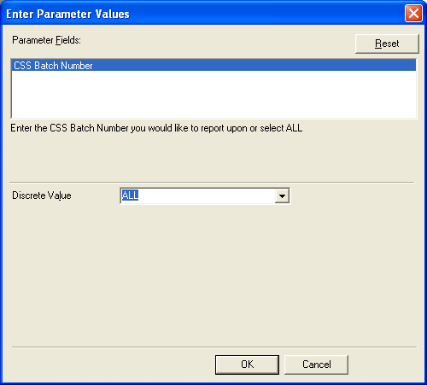
Parameter screens will vary from report to report. The specific report will have more details.

Parameter Fields: There may be more than one. If you highlight one the parameters the related entry field will be presented below. That is where you will enter the criteria.

If there is an ADD button make sure to use it to “Save” your criteria. Otherwise the system knows what you entered.

Dates will have several options displayed but most applications will be to simply enter a range.

Some reports will support Wildcards and for reports that value is the asterisk (*)

PRESS OK when ready to execute the report.

Preview Options
3
1
2
4
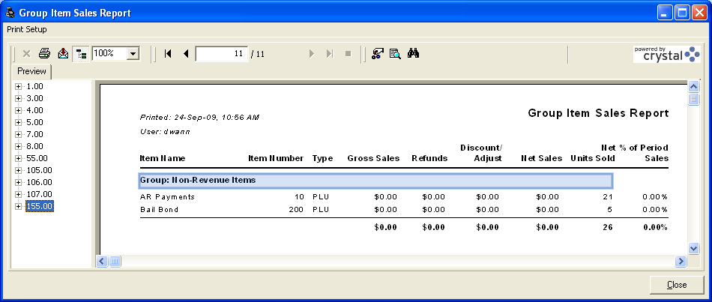
5

- This is an export feature. This documentation will only discuss two of the available options.
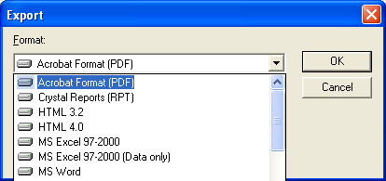

Acrobat Format: This will save the report as an un-updateable format, perfect for storing stats electronically.

MS Excel 97-2000 (Data Only) this format puts column based reports into an easy to use excel format for additional sorting, selection, ect.

Both options will provide a browse window that will let you save the report and provide a name that you prefer for it. Since Crystal Reports is a tool used by multiple business applications further details on its features should be obtained from IT.

- This feature will let you see the left hand display grid or not.
- This area handles navigating from page to page
- Searches the report for text
- Changes from report to report but usually represents the page grouping of the report for quick navigation. This report separates by reset number. Clicking this will navigate you to that page quickly.

Security Audit/ Setup

Security Audit: Role -> Function
Purpose: This report would provide a snapshot of role/user group definitions for security audit purposes.
Section: POS Lists Base Report: POS User Listing Select Name: DC2 Security Audit: Roles

Security Audit: User -> Roles, Locations & Sources
Purpose: There are currently two reports that display the user’s access to the system.
Section: POS Lists Base Report: POS User Listing Select Name: DC1Security Audit: User
Section: POS Lists Base Report: POS User Listing Select Name: DC29 Security Audit: Terminals
The “User” report provides a snapshot of what functions/roles users are assigned. The “Terminals” report lets you see what receipting locations and terminals they have access to. Both reports will allow you to put a partial value in to search the department name and number which is stored in the user address field.

GL Accounts: GL Fund Mapping
Purpose: This report is used to verify fund mapping. Suggest exporting to Excel.
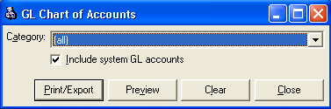

Section: Accounting Base Report: GL Chart of accounts Select Name: DC3 Accounting Setup

Criteria: To view all GL Accounts leave category at all. To select a smaller group:
- Choose Point of Sale Revenue (GL accounts) or Payments (Bank) (Clearing Accounts)
- Uncheck Include system GL Accounts (This removes CLASS
Parameter: Type in “FUND ###“ for a specific mapping group

Evaluating the data:
GL Number starts with….
- FUND: this is used by Miscellaneous GL accounts where the fund is defined at point of sale
- PROMPT: this is a GL account where the X and/or Y are replaced by values and assigned a CCID at point of sale.
- Non-System: This GL entry is used by non-deposit or non-system items like the Deposit Receipt.
- Numeric values represent the CCID the internal number used by Oracle financials for the account code combination represented by the NAME column.

GL Accounts: Oracle/Class Exceptions
Purpose: Use this report to see if there are errors in the hard coded account set up in Class against Oracle.

Section: Accounting Base Report: GL Chart of Accounts Select Name: DC4 Accounting Setup Exceptions

Criteria: Use default criteria

POS Items: (Fee schedules, Accounting, Grouping, Audit & Prompts)
Purpose: Use these reports to validate items. Items are what receipts/transactions are issued for and the Item name is displayed on the receipt. Items are put into groups for setup and reporting purposes. Each department should know what their reporting groups are. Reporting group naming convention used at Dallas County has the department number in front of the group name. DC5 will give you information about all items including accounting, prices and overrides. DC30 will give you information about what information outside of amount is collected at POS this may also include validation tables.

Section: POS Lists Base Report: Item Listing Select Name: DC5 Item Setup
Section: POS Lists Base Report: Item Listing Select Name: DC30 Items with Related Prompts
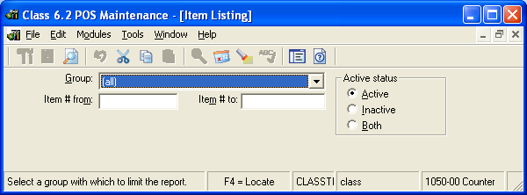

Criteria: This is the recommended
- Group => ALL (Unless you want a specific group)
- Active Status => Active

Parameters:
- Group => This group accepts wildcards (*)
  - All if you want everything
  - 1050* will bring back all the groups that start with 1050 which is also the County Treasurer department number.

What can a deposit source sell and how is it presented?
Purpose: CLASS has three ways to reference items all start with pressing a button. 1) A item to be “sold” is presented directly 2) a list of items are presented and 3) a list of lists that allow the cashier to “Drill” down to a list of items.

All items assigned to a deposit source:
Section: POS Lists Base Report: Item Listing Select Name: DC5 Item Listing
Criteria: Select using the full source name.

Item grouping on the cashier touch screen layout:
Section: POS Lists Base Report: Lookup List Listing Select Name: DC26 Lookup Lists
Criteria: Use Lookup List parameter and “*” to return just the lookup lists that you are interested in.

Lookup List groups: This is one or more drill down lists possibly used by a department
Section: POS Lists Base Report: Parent Lookup List Listing
Criteria: None

Researching & History

Receipt Transactions: Details
Purpose: This produces a columnar report that lists all the attributes about a receipt except the accounting. The sample shows one receipt/transaction the report produces many in two columns.

Section: POS Sales Base Report: Journal Listing Select Name: DC6 Receipts: Detailed
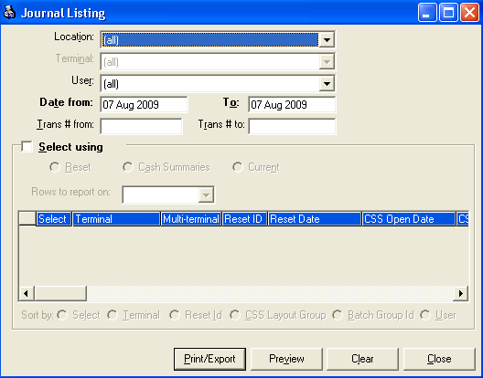
Criteria:
- Date Range: Goes against the transaction date.
  - Searching for receipts within a specific Deposit Warrant.
- The user will select the location they are assigned to (i.e. Auditor) from the location dropdown.
- The Terminal selected from the drop down will be the one the User was logged into.

Receipt Transactions: Cancellations
Purpose: Only returns transactions that have been cancelled. Cancellations mean that the entire receipt/transaction has been voided.

Section: POS Sales Base Report: Journal Listing Select Name: DC7 Receipts: Cancelled

Criteria:

- See common functions for criteria details
- Set Location, Terminal, User to ALL and the date range to see cancellations system wide. The report will be ordered by department and separated by terminal.

Receipt Transactions: Price Adjustments
Purpose: This produces a columnar report that lists all the attributes about a receipt except the accounting. The sample shows one receipt/transaction the report produces many in two columns.

Section: POS Sales Base Report: Journal Listing Select Name: DC8 Receipts: Adjusted

Criteria:
- See common functions for criteria details
- Set Location, Terminal, User to ALL and the date range to see cancellations system wide. The report will be ordered by department and separated by terminal.

Receipt Transactions: ENHANCED (Export, Additional reporting)
Purpose: This report gives receipt details in an excel friendly format for departmental reporting. All items have information in common like payment type, amount, etc. Items can also have information that is unique to it alone. These are called prompts. This export gives you the prompt question and answer (up to 10) so that your department can use this information in additional reporting.

You can run this export for a specific item like Item #9 and see all the receipted deposits for a given date range. You could run this for a specific Prompt group and a date range (NSF Payment) and the extract will return all the collection and fees. Up to 10 questions answered at the time that an item was sold will be available on this extract. Once in excel it could be imported to another system or used in enhanced reporting functions.

Section: POS Sales Base Report: POS Custom Prompt Transaction Report Select Name: DC22 Item Sales Detail: Export
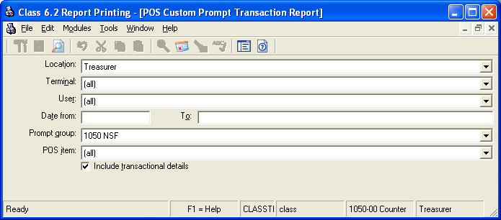

Criteria:
- Enter in desired date range (Always)
- Prompt Group: Don’t use this criteria it will cause the report to abort.
- POS Item (use parameters below it is easier to find the right item.)
- Click on print/export
- A parameter screen will ask for additional criteria: You should only use one of these
  - Item Number
  - Item Name: Use a partial name & * as a wild card.
  - Group: Uses a departmental Item group. You can

Accounting: DC98 Deposit Warrant or CSS
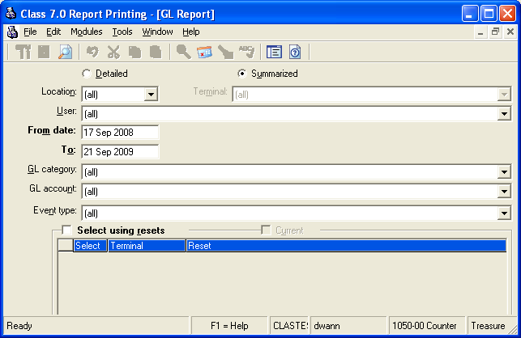

Accounting: Summary by Transaction or Reset Date

Accounting: Transaction Receipt Level

Accounting: (GL Effective Date, Source & Monthly Summary)

The GL Report is the base report for all accounting within CLASS. There are four Dallas County versions of this report that handle the various presentations of that accounting. You must use the Dallas County versions to get the right account code combinations.

Section: Accounting Base Report: GL Report

Criteria: ALWAYS Entered First
- Toggle buttons located at the top of the criteria screen will give you DIFFERENT REPORTS see below.
- GL Category & Event Type: Leave as default they are out of scope for Dallas County Business for the most part.
- GL Account: These criteria can be used to limit the report to a specific GL account. NOTE: If the combination selected has an X or a Y then the report will return all uses of that account combination . There is a wildcard option under parameters that is better.
- Date range: This range can represent the receipting date (default) or Reset Date. If the report being selected keys off another date like GL Effective date then make sure this range includes all transactions or resets that would be included in the reporting range.
- Select using reset (checkbox) This tells the report that the dates entered will be against the RESET date instead of the transaction date. The criteria screen change to display available resets. Deselect any you don’t want.

Report Options
- DC11 Accounting by Receipt (exportable from preview): Reports shows the receipt/payment information and the accounting…
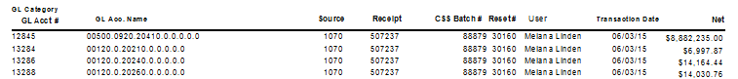
- DC10 Accounting by Month/DC9 Accounting by Month Export. Targets accounting by when it is effective to the Oracle GL it is the only report that does this. This is setup so it can be used to create cross-tab reports.
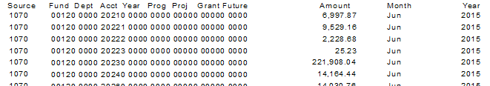
- DC28 Accounting by CSS: This is the most efficient way to report accounting. It is organized by CSS Batch is wonderful if you want to see the accounting for a set of CSS/DC98 Deposit Warrants. This will force the Date to/from to go against the reset date not the transaction date.
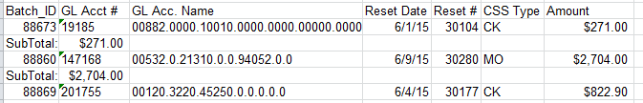
- DC12 Accounting Summarized: No additional totaling or grouping like on DC28. Great for getting accounting totals across many sources or deposits. The debit would be refunds or cancellations and credits represent the receipted amounts. The GL account # is a key value for the GL combination.
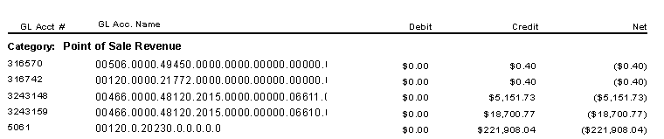
Parameters: Will be on Pop up (Look for on your windows task bar). Reports will not run until you respond to parameters if there are any. You will only see parameters specific to the report selected.
- CSS Parameter. If you know the CSS batch and you only want accounting for a single deposit. Remember criteria will override this parameter. If your deposit is open for a week and you only have 2 days specified on the criteria you will only get two days of accounting even when using this parameter. Leaving this set to ALL will ignore this parameter.
- Account Name: Use this parameter in DC11 to select a specific account segment or set of segments within the GL account name. You will need to use (*) wildcards with this parameter. (i.e. *48010*, 00120.0000.48010* , *12345.2010*)
- Department group This is a special parameter that isn’t currently used. It can be used to link several sources together for reporting as one source. It will default to ALL.
- Account filters the results of the report for a specific account segment i.e. 48010 for all the over/short account usages. Defaults to ALL
- GL Effective Date: defaults to current day. This range should always be smaller than the range selected on the Criteria screen. This is the primary reporting range.

Suspense Accounting: What transactions cause interface issue
Purpose: This report is used to identify transactions where accounting cannot be properly identified by the CLASS – Oracle GL interface. These funds were posted to a suspense account and have to be moved to the proper account once the cause for the problem is identified. This report uses a date range.

Section: System Base Report: Custom Report Select Name: DC27 Suspense Transactions

Items: Total sold – Performance Measures
Purpose: This report is generally used to determine sales for items sold for a period of time (i.e. monthly). It is recommended that each department request the system administrator create a “Group” that lists specific items that they wish to track for their performance measures. Groups are defined by the auditor’s office. By default we use groups to track what items are used by what receipting entities. So it is possible that an item is assigned to multiple groups and if that is the case and you do not specify one of them your statistics may be compounded. This will become clear when you run the report. The Auditor’s Office will assist if you have questions.

Section: POS Sales Base Report: Group Item Sales Report Select Name: DC31 Item Sales Report

Who would run this report: Supervisors would run this report to determine location based item count & totals.
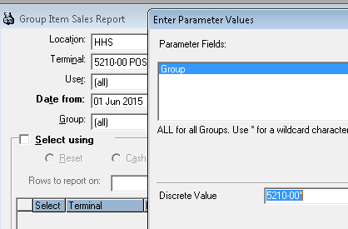
Criteria:
- If you are doing department level reporting it is best always indicate the department/location. Some items are shared across departments.
- Use Group for a specific set of items or leave as all for all items sold.

Parameters
The Group parameter accepts wildcards. This may be easier to use than the group drop down.

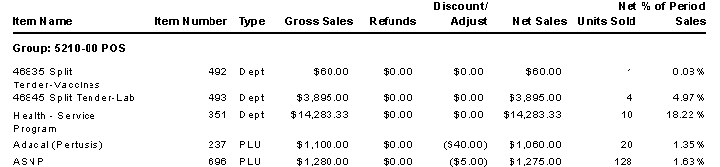

DC23 Item Sales Summary: Prompts
Purpose: Reports totals by Item for a given date range where the amount is derived from the Amount column within a prompt group. Typically these would be non-system transactions ones that do not impact the General Ledger. (Don’t use the prompt group parameter, it will cause the report to abort.)

DC24 Item Sales Detail
Purpose: Reports details at the payment level for a given date range where the amount is derived from the Amount column within a prompt group. Typically these would be non-system transactions ones that do not impact the General Ledger. (Don’t use the prompt group parameter it will cause the report to abort.)
.

Departmental Closeout

Determine On-hand amount totals by Cashier

Departmental Cash Count Audits

Purpose: When cashiers have their own tills the supervisor will need to use this report verify what each till should balance to. Periodically Internal Audit will do a cash count audit and this report will tell them the expected amount on hand during the middle of a receipting period. This report handles historical data but the expected use of the report will involve receipting sessions that have not been closed out and reset.

Section: POS Sales Base Report: Drawer Balance Report
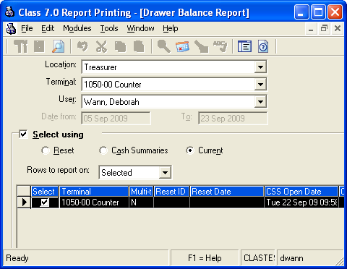
Criteria:
- Must choose location and terminal.
- User:
  - All – Cash Count.
  - User (last name, first name) for separate tills.
- Date (default)
- Check Select Using
- Choose Current
- Check the proper CSS batch group from the returned list scroll to right to see number and CSS Batch data.*

* Normally only one CSS batch group should be pending upon a terminal at a time. If the department must issue receipts while close out occurs there will be two CSS batches until the one going through the closeout process is being reconciled and reset. If there are a number of open CSS then the cause should be determined and resolved.

Receipt/Transaction List (Active/Historical)

Receipt/Transaction List (Multi-Tills)

Purpose: Obtain receipt list under various situations. This report currently does not support multiple in-progress receipting sessions. To resolve out of balance conditions will rely on knowing the CSS Batch number. This can be found on the CSS Layout selection screen discussed at length in the Closeout procedures.

Section: Accounting Base Report: Daily Cash Balance Report (Detail) Select Name: DC16 Payment Listing by Type
Section: Accounting Base Report: Daily Cash Balance Report (Detail) Select Name: DC32 Receipt Recon by Group
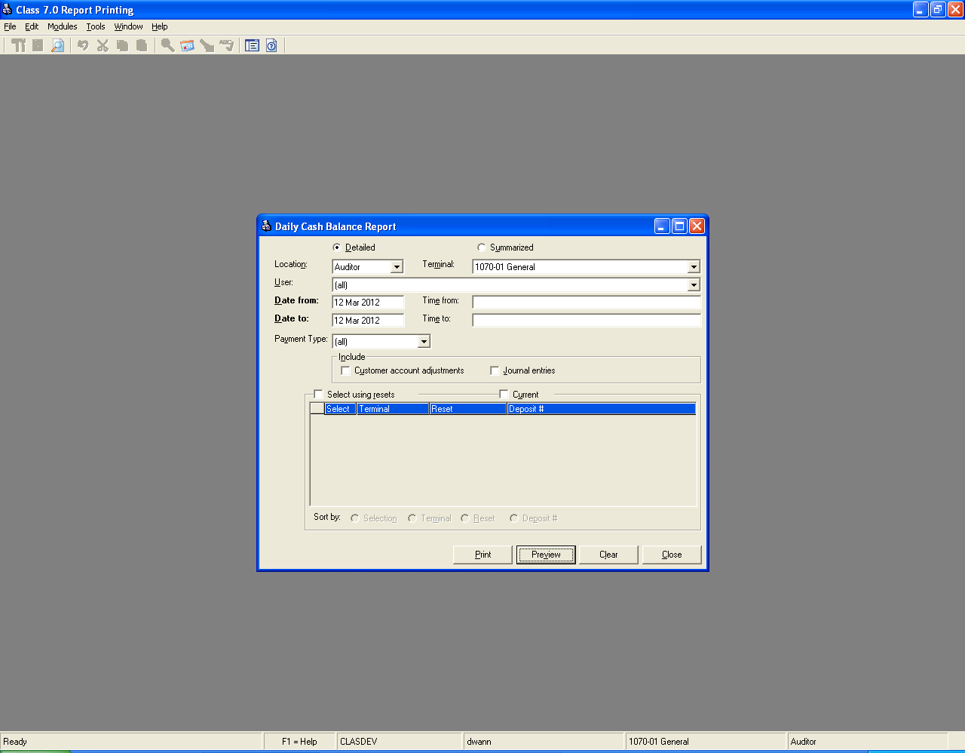

Criteria:
- Select Detailed.
- Make sure the location and terminal are for the receipting session you are trying to reconcile or are set to [all].
Terminal name
- Choose a specific user if you are reconciling a specific cashiers till.
- Date range make wide enough to cover the receipting period it is ok to make really big.
- Click the Preview button.
- DC16 & DC32: Enter the CSS batch # (Optional).
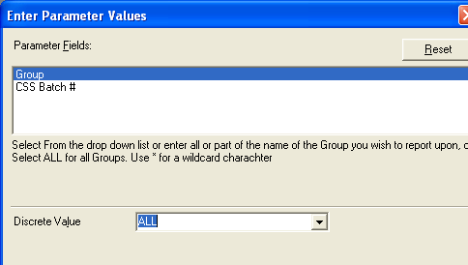
- DC32: Enter the Group full or partial with (*)
  - This will be either a group that represents a Till within a receipting session or
  - Use the Terminal name. This report provides subtotals for each CSS Batch No for easy balancing.

The same process can be used to obtain a receipt list of any completed departmental deposit. Other options are discussed in Common Features.

DC98 Deposit Warrant
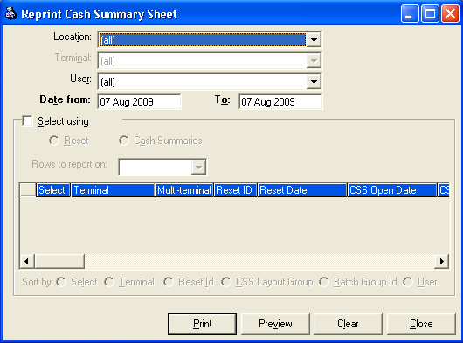
Purpose: Departments must produce a deposit warrant for each payment method collected after the receipting period has been finalized. Details of this process can be found out in the Closeout Procedures. Deposit Warrants can be re-printed or viewed as needed. Whatever report criteria chosen the Deposit Warrant report will return a page for each CSS batch with activity.

Section: POS Sales Base Report: Reprint Cash Summary Sheet Select Name: DC98 Deposit Warrant

Criteria: See Common Features
Parameters:
- CSS Batch #: Use this if you want to reprint just one payment method.

TIP: “Select using” + “Reset” criteria is recommended. Use Print vs Preview if you are creating a deposit since this is an unusually long running process.

TIP: If you are having trouble getting an expected Deposit Warrant try using the date range of the beginning and end of you deposit session and CSS Batch# parameter.

TIP: The Treasurer will accept the DC28 report in place of the Deposit Warrant when technical issues prohibit timely reporting of the deposit warrant. Call the Deposit desk and they can walk you through what you have to put on the report manually in these special situations.

Bank Deposit Management & Research

Distribution of Funds from a payment Channel (Deposit to Cash)
Purpose: The Bank Distribution Report is used to tell the Treasurer what fund

Section: System Base Report: Custom Report Select Name DC19 Bank Distribution: Deposit
Criteria: Enter the deposit number assigned on the Bank Deposit screen when prompted for a discreet value.

Proof of Cash – Daily impact from all payment channels
Purpose: This report will help identify the total expected to be received by each Fund bank account for the date range entered.
Section: System Base Report: Custom Report Select Name DC20 Bank Distribution: Date
Criteria: Used by supervisors to determine bank account distribution for deposits.
- Enter a date range: This should represent the day being reconciled.

List Departmental deposits within a Bank Deposit
Purpose: Provides the detail listing of each CSS and Treasurer Receipt within a bank deposit.
Section: POS Sales Base Report: Reprint Cash Summary Select Name: DC15 Bank Deposit: CSS List
Criteria: Enter the deposit number assigned on the Bank Deposit screen when prompted for a discreet value.

Locate Departmental Deposits not received/processed by Treasurer

Determine the CSS batch number after Departmental Reset

Locate Receipting Sessions not properly closed out
Purpose: The Deposit Management Report is really three different reports two that have Dallas County versions. Discussion of these versions and the Select names will be done in the Criteria section.
Section: Accounting Base Report: Deposit Management Report Select Name: (See Report block for DC report name)

Criteria:
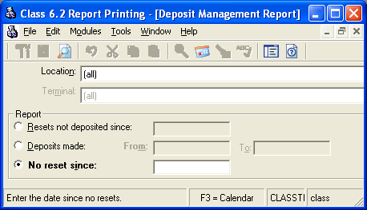
- Location: If you are a department researching your own deposit history you will want to use the location criteria otherwise the recommendation is to set this to [all].

Report block:
Resets not deposited since: Returns departmental deposits that have been finalized by the department but not receipted or deposited by the Treasurer.
Report Block
Select Name: DC13 CSS Deposit Status

- Date: Left blank will pull CSS deposits up to yesterday. If looking for a current day reset use tomorrows date.

Deposits made: Don’t use this report

No reset since: This should be used as an exception report to ensure that departments are performing proper and timely close out processes. A department that has pending receipting sessions that should be closed may need additional training or assistance.
- Date (typically 7 days prior to current date to avoid receipting sessions in normal process.)

History of Department to Bank Deposit activity

Purpose: Supports research into when CSS were reset by the department, accepted by the Treasurer and deposited to the bank and related control numbers. DC25 exports report data to Excel. (The default directory C:\Documents and Settings\All Users\Desktop\DC25 Extract.csv may not be accessible choose My documents or another directory using the Browse button.)

Section: System Base Report: Custom Reports Select Name: DC17 CSS Deposit Status
Section: System Base Report: Custom Reports Select Name: DC25 CSS Deposit Status Export

Parameters:
- Date Range: (Required) Based on when the County Treasurer completed the bank deposit process. If the departmental deposit has not been completely processed by the County Treasurer it will not be on this report. Use DC13 Deposits in progress to see if the Treasurer has received it or not.
- Bank Deposit Type: This list represents the banking types used by the County Treasurer. If you are not using a specific banking type leave as ALL
- Terminal: This parameter will let use the (*) wildcard to indicate a specific source department or terminal. 1050* would return all CSS for the County Treasurer 1070-00* would return a specific deposit source.

