1. vTap on **Settings**

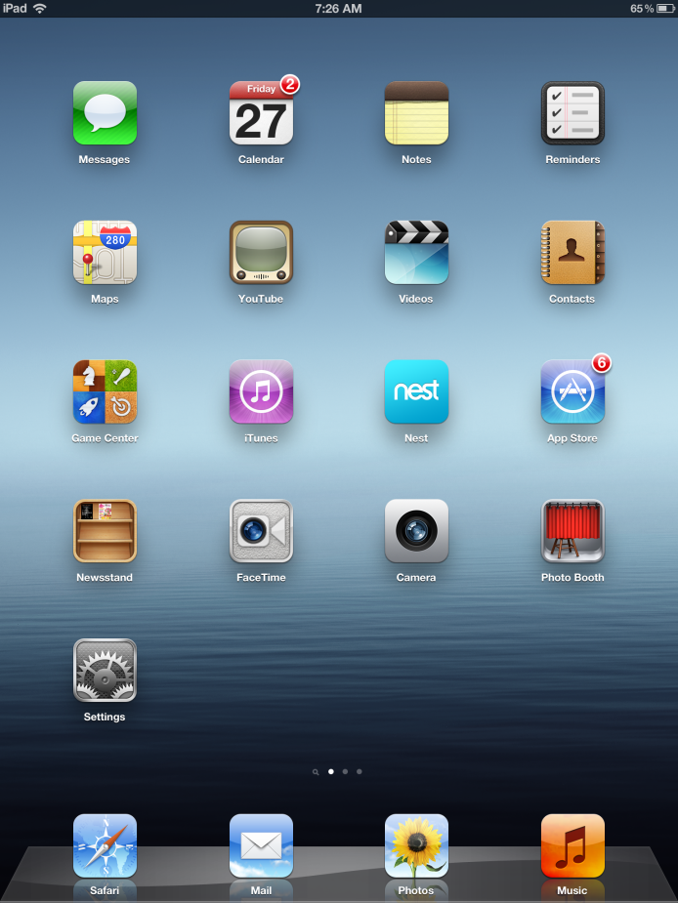

1. Turn on **Wi-Fi**

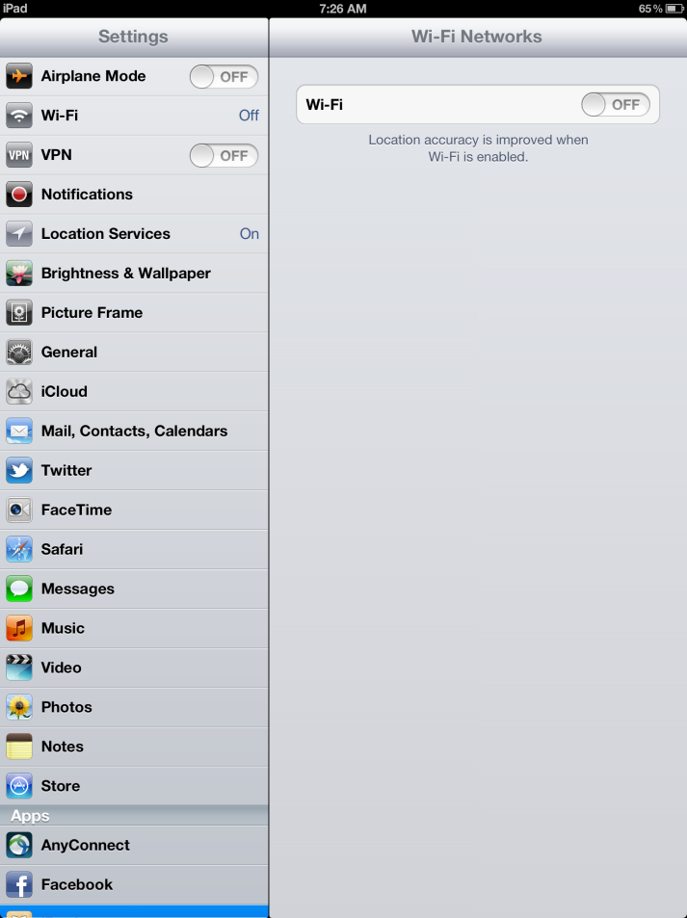

1. Tap **Other**

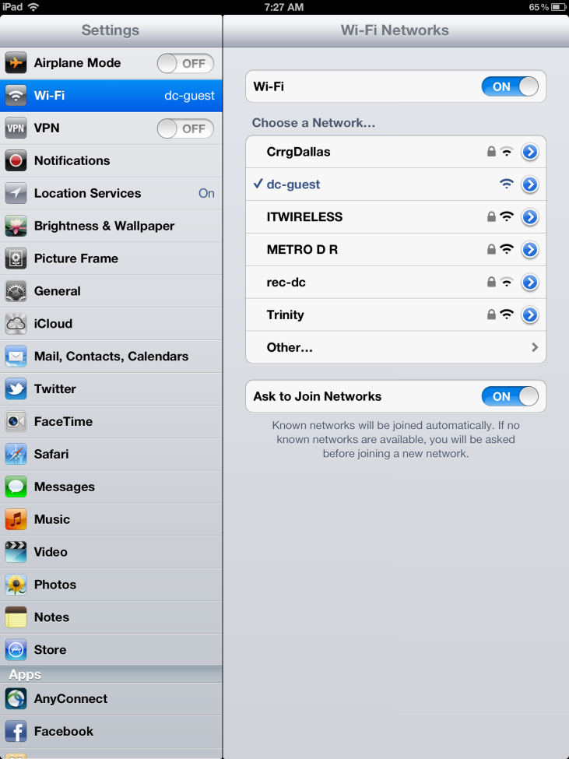

1. Type in the Name box: **guest-attny**

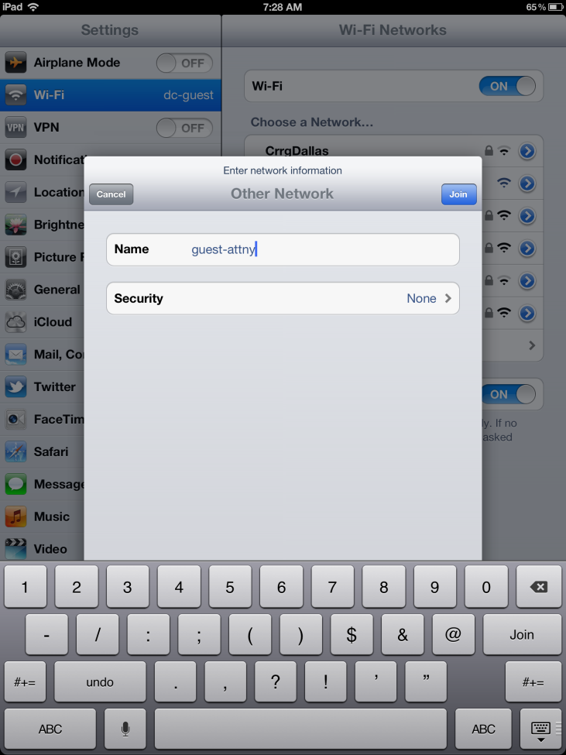

1. For Security select: **WEP** and tap on **Other Network**

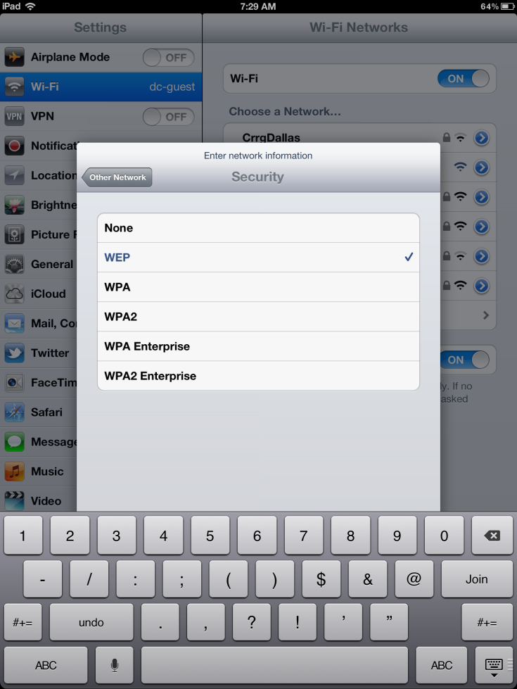

1. Type in the Name box: **guest-attny**

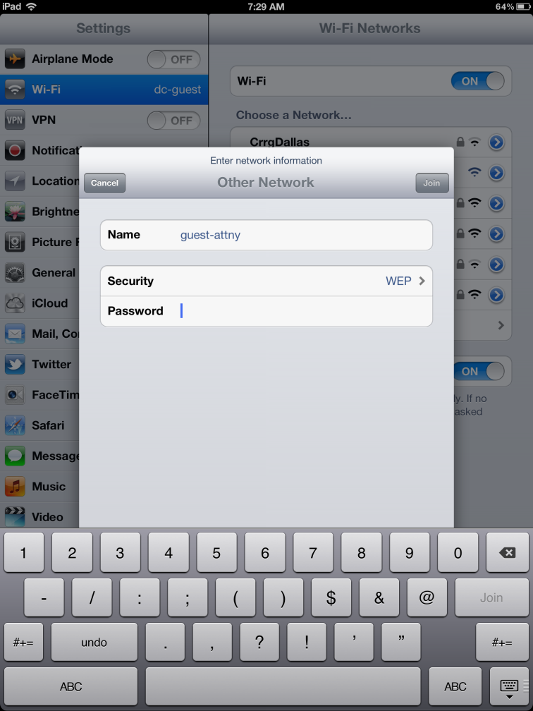

1. Type in Password box: **6174746F72** and Tap Join

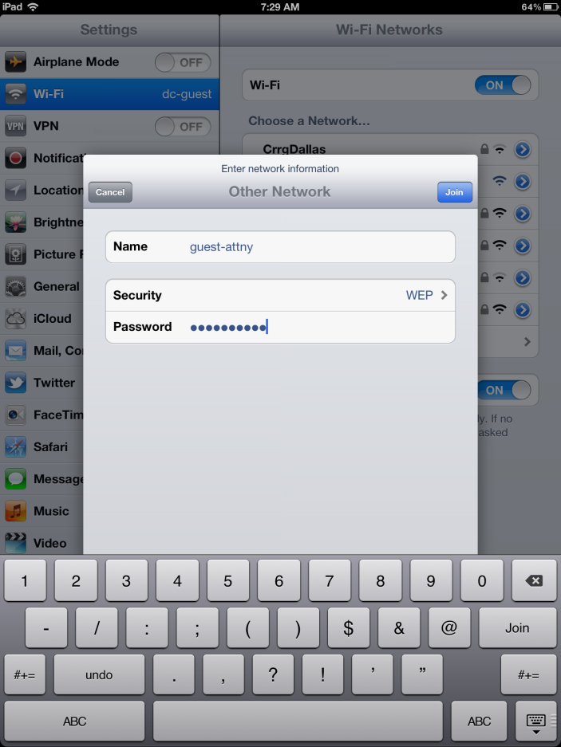

1. You should see the **check box** meaning that you are now connected.

