Contacts
Christian Grisales, Public Information Officer
PIO_DCHHS@dallascounty.org

Dr. Philip Huang, Director

FOR IMMEDIATE RELEASE

DCHHS Confirms Mosquito Samples Test Positive for West Nile Virus

Ground Spraying is Scheduled in Balch Springs and Sachse

DALLAS (June 25, 2024) – The Dallas County Health and Human Services (DCHHS) laboratory has confirmed mosquito samples that have tested positive for West Nile Virus. The mosquito samples were collected from the 75180 and 75048
zip codes in Balch Springs and Sachse, TX. In conjunction with the Dallas County municipalities, mosquito abatement teams are responding by treating impacted areas. DCHHS has scheduled ground spraying in the below area(s), weather permitting.

Residents should remain inside during the time sprayers are in the area. Spraying will not be conducted in the event of wind speeds more than 10 mph or inclement weather. Click on the link to view a map of the spraying areas: http://www.dallas.leateamapps.com/PublicMap/

Dallas County is experiencing high mosquito activity, and residents should take the necessary precautions when spending time outdoors to avoid mosquito bites that may cause West Nile Virus. Dr. Philip Huang, Director of DCHHS, recommends following the four Ds to prevent mosquito bites.
- DEET: Whenever outside, use insect repellents that have the active ingredient DEET or other EPA-registered repellents, and always follow label instructions.
- DRESS: Wear long, loose, and light-colored clothing outside.
- DRAIN: Drain or treat all standing water in and around your home or workplace where mosquitoes could lay eggs.
- DUSK to DAWN: Limit your time outdoors from dusk to dawn when mosquitoes are most active.

DCHHS encourages residents in affected areas to be a part of the solution by eliminating insect breeding areas and larvae before they develop into adult, flying mosquitoes. Standing water can be treated with EPA-approved larvicides that are available for retail purchase.

Larvicides are products used to kill immature mosquitoes before they become adults. Larvicides are applied directly to water sources that hold mosquito eggs, larvae, or pupae. When used consistently, larvicides can help reduce the overall mosquito burden by limiting the number of mosquitoes that are produced, according to the Centers for Disease Control and Prevention (CDC).

For more information visit our website:
https://www.dallascounty.org/departments/dchhs/communicable-diseases/west-nile-watch/west-nile-watch-24.php

Bach Springs

June 25 & 26 2024 9:00 pm - 5:00 am

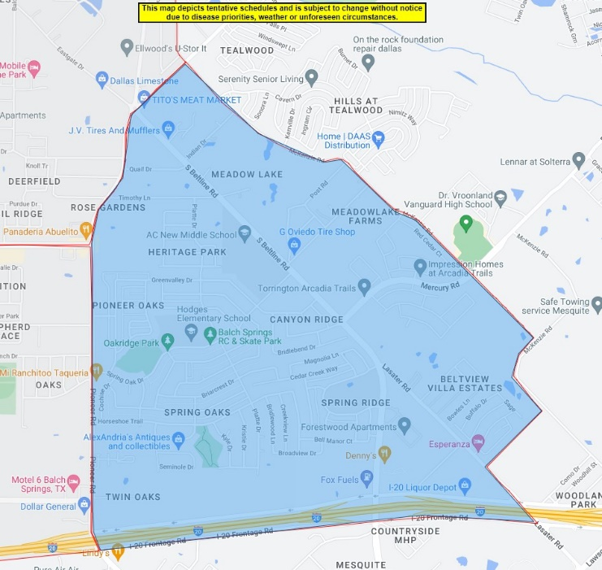

Sachse

June 25 & 26 2024 9:00 pm - 5:00 am





