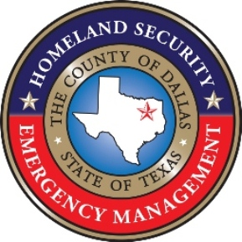
OFFICE OF HOMELAND SECURITY AND EMERGENCY MANAGEMENT
Local Emergency Planning Committee
2121 Panoramic Circle, Suite 240,
Dallas, Texas 75212-5705
Phone: (214) 653-7980 - Fax: (214) 653-7988
bernardo.salazar@dallascounty.org

Dear Dallas County Tier II Community:
The Dallas County Local Emergency Planning Committee (LEPC) and Dallas County Homeland Security and Emergency Management office remind you that the annual deadline to file Tier II reports under the Emergency Planning and Community Right-to-Know Act (EPCRA) is April 1st, 2022.
According to the Texas Commission on Environmental Quality (TCEQ), facilities must submit their reports using the new State of Texas Environmental Electronic Reporting System (STEERS). This replaces the EPA’s Teir2Submit software used in the past. For more information regarding the process, please visit https://tceq.texa.gov/permitting/tier2 .
We remind facilities that the law requires them to submit their report and coordinate their emergency plans with the LEPC and local fire department and/or emergency management office. You must provide your report to TCEQ, the LEPC and the local fire department. You can send your report to the LEPC at Bernardo Salazar <Bernardo.Salazar@dallascounty.org>
In addition to your reporting requirements, EPCRA also requires all facilities subject to the law to participate in their local LEPC. Please visit https://www.dallascounty.org/departments/hsem/lepc/ for information on upcoming LEPC meetings.
To assist facilities in meeting this important annual requirement, a Common Errors in Tier II reports Accuracy in reporting document is attached. Please consult this document and the information provided by TCEQ at https://www.tceq.texas.gov/assets/public/permitting/tier2/commondef.pdf prior to submitting TIER II reports.
Accuracy in reporting is essential to our community planning and preparedness for a chemical emergency.
We have also included the EPA Determining location site https://www.epa.gov/rmp/determining-facilitys-latitude-and-longitude to assist facilities in providing an accurate location.
In providing a CAS number response teams are better equipped, the following link provides access to CAMEO for CAS number searches https://cameochemicals.noaa.gov/search/simple.
If you have further questions or require assistance in completing your Tier II report, please contact Bernardo Salazar <Bernardo.Salazar@dallascounty.org>
Sincerely,


Bernardo Salazar
Dallas County Hazardous Materials Planner

