

**JUSTICE OF THE PEACE 2-1**

**REQUEST FOR COMMUNITY SERVICE**

The court will consider alternative methods to discharge fines and court cost owed for a traffic or other class c misdeamenor conviction. The Judge must approve the request. The Defendant(s) must submit their request either through mail or in person. The Court cannot consider oral request.

**STEPS TO REQUESTING COMMUNITY SERVICE**

1. **PLEA OR FINDING OF GUILT/NO CONTEST** -The Defendant must have a plea or finding of guilt in the cause pending before the Court.
2. **MAKE A REQUEST IN WRITING** - The Defendant must make a written request of community service to the court.
3. **COMPLETE AN AFFIDAVIT OF INDIGENCY**. - The Defendant must complete an affidavit of indigency.
4. **JUDGE MAKES A FINDING OF INDIGENCY** - The Judge must make a finding of indigency in order to grant you community service.

**ONCE COMMUNITY SERVICE IS GRANTED**

1. **COMPLETE COMMUNITY SERVICE -** Once community service is granted, the Defendant may work at a nonprofit organization to satisfy a citation.
2. **PROVIDE THE COURT WITH EVIDENCE OF COMPLETION –** Return to the court on or before the due date with a letter or a form demonstrating completion of community service.

**OTHER INFORMATION**

1. **STILL ELIGIBLE FOR DEFERRED DISPOSITION –** Satisfying fines and court cost through community service does not preclude a Defendant from qualifying for a deferred disposition (meaning compliance with the court order will not result in a conviction on a driving record).
2. **DRIVER’S LICENSE HOLDS –** The Court will automatically release a hold on a driver’s license once community service is complete.

**CAUSE NUMBER:**  **JT/JM/JW ____________________D**

|  |  |  |
| --- | --- | --- |
| **State of Texas**  **Vs.**  **____________________________________**  ***Defendant*** | **§**  **§**  **§**  **§**  **§** | **IN THE JUSTICE COURT**  **PRECINCT 2, PLACE 1**  **DALLAS COUNTY, TEXAS** |

**DEFENDANT’S MOTION FOR COMMUNITY SERVICE**

**ON THIS DAY,** the Defendant request that the Court considers a request for community service as an alternative to payment of fines and court cost in the above and entitled cause of action.

In support of this motion, the Defendant submits a statement of inability to pay fines and court cost demonstrating that the Defendant is indigent and that making payments would impose an undue hardship on the Defendant and/or the Defendant’s family.

The Defendant in support of this motion states that he/she is able to perform community service and that he/she understands that the court will not release a hold on a driver’s license until such time as community service is completed.

**PRAYER**

I pray that the court grants my request for community service.

**SIGNED ON THIS DAY**: ____________________________.

My name and address are as follows:

|  |  |
| --- | --- |
|  | *Signature* |
|  | *Printed Name* |
|  | *Street Address / City / State / Zip* |
|  | *Phone Number / Fax Number / Email* |

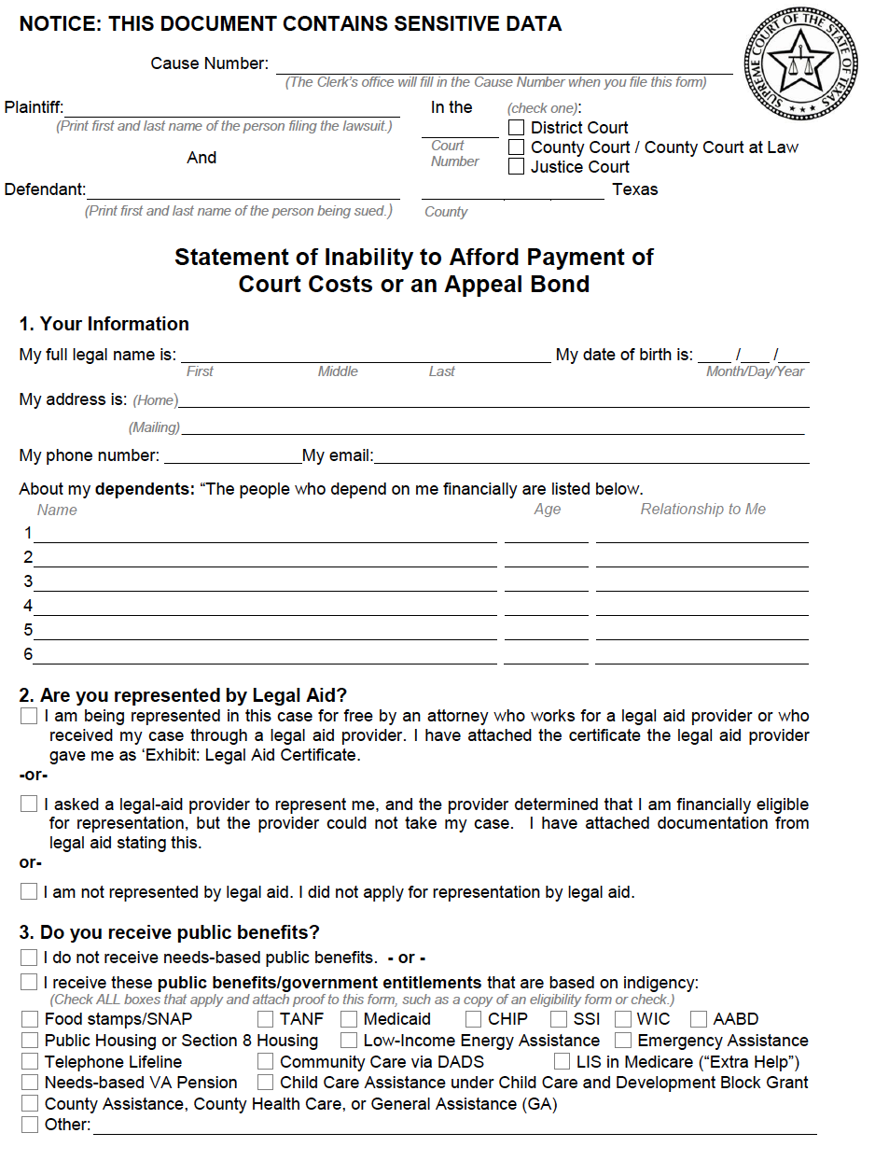

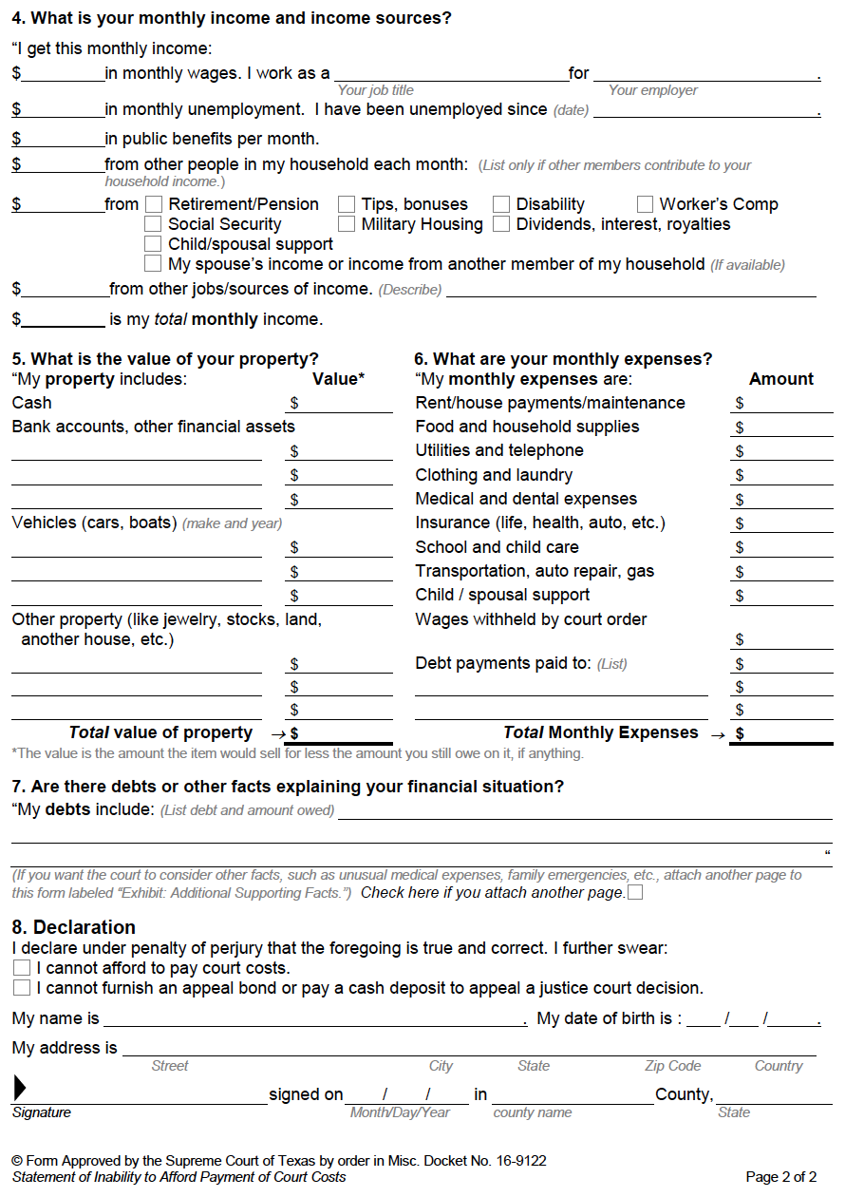

The Court will accept a timesheet from an agency in lieu of using the timesheet provided.

Defendant Name: ___________________________________________

**Community Service Rules**

While performing community service, I will contact the provider I choose to arrange community service as soon as possible; arrive on time; obey the site supervisor; not leave the worksite without permission; not carry any sort of weapon; Not use abusive language; wear appropriate clothing to work; apply for authorization for extension of time if needed; contact the Court with any questions.

Community Service Provider: ___________________________________________

Telephone: ___________________________________________

|  |  |  |  |
| --- | --- | --- | --- |
| **Date** | **Time In** | **Time Out** | **Total Hours** |
|  |  |  |  |
|  |  |  |  |
|  |  |  |  |
|  |  |  |  |
|  |  |  |  |
|  |  |  |  |
|  |  |  |  |
|  |  |  |  |

I certify that the above record is a true representation of the number of hours worked for the above period by the defendant.

**Community Service Provider Information**

Printed Name: ___________________________________________

Signature: ___________________________________________

Phone Number: ___________________________________________