OCCUPATIONAL LICENSE FILING PROCEDURES
The Court offers Occupational License hearings by appointment and by submission. Please call the court to make an appointment 214-643-4773.

STEPS TO REQUESTING AN OCCUPATIONAL DRIVER’S LICENSE
- COMPLETE PAPERWORK -The petitioner completes and files a petition for Occupational Driver’s License.
- PROVIDE SR22 INSURANCE - The petitioner shall provide the court with SR22 insurance from an insurance company.
- PROVIDE DRIVING RECORD - The petitioner shall attach a driving record. Please obtained your driving record through the Texas Department of Public of Public Safety website at https://www.dps.texas.gov/section/driver-license/how-order-driver-record
- PAY/COST – The cost to file the petition for ODL is $66.00, $5.00 for certified copies, and The cost varies depending on what the petitioner needs.
- APPEAR AT A HEARING or BY SUBMISSION –The Court holds hearings on Friday from 9:00–11:00 am, however, the Court may consider cases by submission.
- PROVIDE A MONEY ORDER OR CHECK FOR DPS – The petitioner may provide the Court the cost for the issuance of the Occupational Driver’s License for the Texas Department of Public Safety. The cost for a one-year suspension is $10.00. The cost for a two-year suspension the cost is $20.00. Checks and/or money orders need to be made payable to the Texas Department of Public Safety and include the petitioner’s name, address, and driver’s license number.

This Court DOES NOT have jurisdiction to issue and Occupational Driver’s License when the reason for suspension is: a mental or physical disability; conviction for a DWI, Intoxication Assault or Intoxication Manslaughter.

The Judge may deny the request for an Occupational Driver’s License for any reason, the issuance of an Occupational Driver’s License is discretionary.

CAUSE NO. ____________________
EX PARTE | § | IN THE JUSTICE COURT
 | §
 | § | PRECINCT 2, PLACE 1
 | §
PETITIONER’S NAME | § | DALLAS COUNTY, TEXAS

PETITION FOR OCCUPATIONAL LICENSE
PETITIONER, seeks an occupational license from this court based on the information provided below. (You must swear that the information you provide in this petition is true and correct. Failure to provide true and accurate information may result in criminal penalties.)

1. ABOUT THE PETITIONER

_______________________________________________________________________________
Full Street Address, Include Apartment Number

_______________________________________________________________________________City, State, Zip Code

_______________________________________________________________________________Phone Number/Fax Number/Email

_______________________________________________________________________________Date of Birth / Driver’s License Number

I am employed, and my occupation is _______________________________________
I am the primary caretaker of children less than 16 years of age.
I have been ordered by a magistrate to install an ignition interlock device on my vehicle, and/or not to operate any vehicle which is not equipped with an ignition interlock device.
I have not been ordered by a magistrate to install an ignition interlock device on my vehicle, and/or not to operate any vehicle which is not equipped with an ignition interlock device.
I have a commercial driver’s license.
I need a driver’s license to get to and from work and/or to perform essential household duties.

2. REASON(S) FOR DRIVER’S LICENSE SUSPENSION
My driver’s license has been suspended as the result of an arrest for an intoxication- related offense in County, because:
A peace officer requested a sample of my breath or blood and I refused; or
provided a sample of my breath or blood, and the sample contained an alcohol concentration greater than 0.08.
My driver’s license has been automatically suspended as the result of a conviction for Driving While Intoxicated (DWI) in a County or District Court.
My driver’s license has been suspended as the result of a conviction for a criminal offense in a justice or municipal court. (Please provide information regarding this offense, including the name of the court in which you were convicted, the cause number, and the type of offense, below.)

My driver’s license has been suspended as the result of a physical or mental disability.
My driver’s license has been suspended as the result of a conviction for Racing on a Highway.
My driver’s license has been suspended because a court found that I am a “habitual violator of traffic laws.”
My driver’s license has been suspended because a court ordered me to attend a Driver Education Program and suspended my license for 365 days.
My driver’s license has been suspended because of a failure to pay surcharges ordered by the State of Texas.
My driver’s license has been suspended for another reason, described below:

3. ESSENTIAL NEED
(Note: In order to obtain an occupational license, you must demonstrate an essential need to operate a motor vehicle. The Texas Transportation Code defines “essential need” as the “need of a person for the operation of a motor vehicle: (A) in the performance of an occupation or trade or for transportation to and from the place at which the person practices the person's occupation or trade; (B) for transportation to and from an educational facility in which the person is enrolled; or (C) in the performance of essential household duties.” In order to demonstrate an essential need to operate a motor vehicle, you may attach additional documentation, such as a letter from your employer. If you attach additional documentation, be sure to check the appropriate box in Section 5 of this petition.)

I am seeking this occupational license in order to (check all that apply):
Travel to and from my place of work;
Perform the duties of my job;
Travel to and from school; or
Perform essential household duties.

The following are addresses and descriptions of all destinations to which I seek to
travel with my occupational license:

My work or school schedule is the same every week: I work or attend school during the following hours on the following days of the week (check all that apply):
  - Monday:
  - Tuesday___________________________________________________________
  - Wednesday:
  - Thursday:
  - Friday:
  - Saturday:
  - Sunday:

- My work or school schedule varies from week to week. (If you check this box, provide a general description of your work or school schedule below, including the total number of hours you work or attend school each week, days of the week on which you never work or attend school, days of the week on which you always work or attend school, and the earliest time your work or school day begins and the latest time your work or school day ends.)

.
- My job duties include automobile travel. My employer requires me to travel by automobile to perform the following tasks:

.
- I perform the following essential household duties:

.
- In order to perform the essential household duties described above, I must travel by automobile during the following hours on the following days of the week (check all that apply):
  - Monday: _
  - Tuesday:____________________________________________________________
  - Wednesday:
  - Thursday:
  - Friday:
  - Saturday:
  - Sunday:
- In order to:
  - Travel to school;
  - Travel to my place of work;
  - Perform my job duties; or
  - Travel to the place I perform essential household duties;
I must travel by automobile to or through the following Texas counties (please fully describe all counties and routes traveled):

____________________________________________________________________________

Section 4. Suspension History
My driver’s license has previously been suspended for:
- A second or subsequent conviction for Driving While Intoxicated (Section 49.04, Penal Code); Intoxication Assault (Section 49.07, Penal Code), or Intoxication Manslaughter (Section 49.08, Penal Code), committed within five years of a previous conviction for Driving While Intoxicated (Section 49.04, Penal Code); Intoxication Assault (Section 49.07, Penal Code), or Intoxication Manslaughter (Section 49.08, Penal Code).
In the past five years, my license has been suspended for:
- A refusal to submit to the taking of a breath or blood specimen following an arrest for an offense prohibiting the operation of a motor vehicle or an offense prohibiting the operation of a watercraft while intoxicated, under the influence of alcohol, or under the influence of a controlled substance.
- An analysis of a breath or blood specimen showing an alcohol concentration of .08 or above, following an arrest for an offense prohibiting the operation of a motor vehicle or watercraft while intoxicated.
- A conviction for Driving While Intoxicated (Section 49.04, Penal Code); Intoxication Assault (Section 49.07, Penal Code), or Intoxication Manslaughter (Section 49.08, Penal Code).
- A conviction for an offense other than Driving While Intoxicated (Section 49.04, Penal Code); Intoxication Assault (Section 49.07, Penal Code), or Intoxication Manslaughter (Section 49.08, Penal Code) prohibiting the operation of a motor vehicle or watercraft while intoxicated, under the influence of alcohol, or under the influence of a controlled substance.

Section 5. Additional Documents.
- I have obtained evidence of financial responsibility, which is attached to my petition. (Note: You may not be issued an occupational license unless you obtain evidence of financial responsibility.)
- I have attached a certified copy of my driving record to this petition. (Note: the court cannot grant your petition without reviewing your driving record.)
- I have attached documents which demonstrate my essential need to operate a motor vehicle.
- I have attached other documents, which are described below:

PRAYER

WHEREFORE, PREMISES CONSIDERED, Petitioner prays that this Honorable Court grant this Petition for Occupational License, and to send a certified copy of this Petition, along with its order granting petitioner’s occupational license to the Department of Public Safety of Texas.

Petitioner’s Signature

UNSWORN DECLARATION
(Texas Civil Practice and Remedies Code, Section 132.001)
Name: __________________________________ Date of Birth: __________________________
Address:________________________________________________________________________

I declare under penalty of perjury that all information in the attached document titled, Petition for Occupational Driver’s License, is true and correct.

Signed in County ________________________, State on this date: ________________________

Petitioner’s Signature

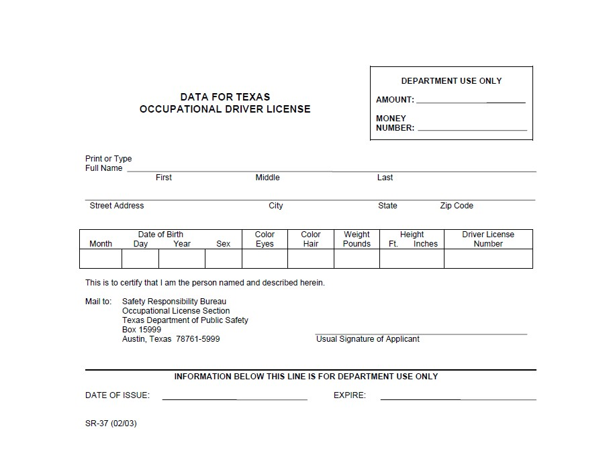

SAFETY RESPONSIBILITY BUREAU OCCUPATIONAL LICENSE SECTION
TEXAS DEPARTMENT OF PUBLIC SAFETY
BOX 15999
AUSTIN TX 78761-5999

