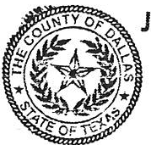
UDGE JUAN JASSO ;-Jp 5-2 702 EJEFFERSON BLVD
FOR COURT USE ONLY:
CASE NOvfCt - t}.2.
PRECINCT/COUNTY------
SUITE 2100
DALLAS TX 75203

Phone:214-q 3-548t
PETITION: SMALL CLAIMS CASE
In the Justice Court, Precinct 5 Place 2, Dallas County, Texas

PLAINTIFF (DEMANDANTE)

vs.
DEFENDANT(S) (DEMANDADO_) _
If Corporation/Company... Need Agent's name to be served

DEFENDANT(s) Address/City/State/Zip _

COMPLAINT: The basis for the claim which entitles the plaintiff to seek relief against the defendant is:

RELIEF: Plaintiff seeks damages in the amount of$. a,nd/or return of personal property
as described as follows (be specific): , which has a value of$ _

SERVICE OF CITATION: Service is requested on defendants by personal service at home or work or by alternative service as allowed by the Texas Justice Court Rules of Court. Other addresses where the defendant(s) may be served are:

[ ]Ifyou wish to give your consent for the answer and any other motions or pleadings to be sent to your email address, please check this box, and provide your valid email address: _

Plaintiff Printed Name Signature of Plaintiff
DEFENDANT(S) INFORMATION (if known):
DATE OF BIRTH: / / Address of Plaintiff

La. t 3 Numgers of Social Security: _
Last 3 Numbers of Driver License: ---
Defendant's Phone Number: ----- City State ZIP

Phone & Fax No of Plaintiffs

I

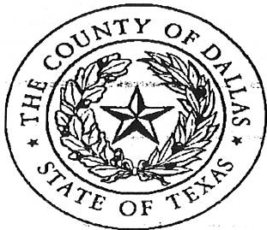
PLAINTIFF
CAUSE NO. J PCZi:3

§
§

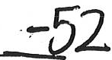

IN THE JUSTICE OF THE PEACE

vs. | §  §  §  § | PRECINCT 5, PLACE 2
DEFENDANT | § | DALLAS COUNTY, TEXAS

MILITARY STATUS AFFIDAVIT

Plaintiff, or Plaintiff's representative, being duly sworn on oath deposes and says that, to the best of my knowledge, Defendant(s)•

is not in the military

is not on active duty in the military

is not in a foreign country on military service

is on active duty and/or is subject to the Service members Civil Relief Act of 2003

has waived his rights under the Service members Civil Relief Act of 2003

military status is unknown at this time

Signature of Plaintiff/ Representative

SUBSCRIBED AND SWORN TO before me on this
- day of ,20

NOTARY PUBLIC FOR THE STATE OF TEXAS OR CLERK OF THE COURT

Department of Defense Service Members Civil Relief Act Website: https:I I www.dmdc.osd.mil.a(!pj/ scra/

Penalty for making or using a false affidavit -A person who makes oruses an affidavit knowing it tobe false, shall be fined as provided in Title 18 United States Code, or imprisoned for not more thanone year, orboth.

